|  |
| --- |
| User Manual  Order to cash(User wise) |
| REFERENCE: GW/ERP/USER MANUAL |
|  |
| **Genweb2 Ltd.** |
|  |



|  |
| --- |
|  |

# Document Information

|  |  |
| --- | --- |
| Document Name | User manual for Order to cash(User wise) |
| Document Author | Rashedul Alam |
| Document Version | 1.1 |
| Release Date | 11th Dec, 2018 |

|  |  |
| --- | --- |
| Review by | Md. Matiar Rahman |
| Review Date | 12th Dec, 2018 |
| Approved By |  |
| Approval Date |  |

# Document History

|  |  |  |  |  |  |
| --- | --- | --- | --- | --- | --- |
| A=Added, M=Modified, D=Delete | | | | | |
| **Version No** | **Date** | **Section No** | **A/M/D** | **Description of Change** | **Author** |
| 1.0 | 11-April-2018 |  | A | Initial | Rashedul Alam |
| 1.1 | 11-Dec-2018 |  | A |  |  |

Contents

A. Document Information 2

B. Document History 2

1. Introduction 5

1.1 Purpose of User Manual 5

2. Customer 5

2.1 Customer creation by Customer Manager 5

3. Products 7

3.1 Product creation by Product Manager 7

4. Customer credit limit 9

4.1 Create customer credit limit by Sales Executive/Head of sales 9

4.2 Customer credit limit approval by Head of Sales 10

4.3 Customer credit limit Validate by Head of accounts 11

4.4 Customer credit limit approve by CXO 12

5. Customer Commission 13

5.1 Create customer commission by Sales executive/Head of sales 13

5.2 Customer commission approval by Head of Sales 15

5.3 Customer commission Validate by Head of accounts 15

5.4 Customer commission approval by CXO 16

6. Product Sales Pricelist 18

6.1 Create product sales pricelist by Sales executive/Head of sales 18

6.2 Product sales pricelist Approve by head of sales 19

6.3 Product sales pricelist Validate by Head of accounts 20

6.4 Product sales pricelist Approve by CXO 21

7. Variant history 22

7.1 Variant history view by Sales user 22

8. Generate commission 23

8.1 Create Generate commission by Accounts executive/Head of accounts 23

8.2 Generate commission Approve by Accounts executive/Head of accounts 24

9. Proforma Invoice 25

9.1 Create Proforma Invoice by Sales executive 25

10. Sales Order 26

10.1 Create sales order by Sales executive 26

10.2 Sales order approval by head of sales 28

10.3 Sales order validate by head of account 29

10.4 Sales order approve by CXO 30

11. Delivery Authorization 31

11.1 Create DA by Account head/Account Executive 31

11.2 DA Approval by Account head 32

12. Delivery Order 33

12.1 Delivery order view by accounts executive/accounts head 33

13. Delivery Chalan 34

13.1 Delivery chalan create by delivery man 34

14. Delivery Schedules 35

14.1 Create Delivery Schedule by Sales executive 35

15. Delivery Instruction 37

15.1 Delivery instruction view by Delivery operation 37

16. Customer Payments 37

16.1 Create Customer payment by Accounts executive 37

17. Cheque Received 38

17.1 Cheque Received by Accounts executive 39

18. Customer Invoice 40

18.1 Customer Invoice Validate by Accounts executive 40

19. Reports 41

19.1 Sales Order reports view by Sales executive 41

19.2 Customer credit limit reports view by Admin 42

19.3 Customer commission reports view by Admin 43

19.5 Product sales pricelist reports view by Sales executive 44

19.6 Delivery authorization reports view by account head 45

19.7 Sales reports view by sales executive 47

19.8 Daily reports view by Admin 47

19.9 Monthly Daily reports view by Admin 49

# 1. **Introduction**

The User Manual contains all essential information for the user to make full use of the information system. This manual includes a description of the system functions and capabilities, contingencies and alternate modes of operation, and step-by-step procedures for system access and use.

## Purpose of User Manual

The purpose of this User Manual is to clearly identify the customer requirements and provide a detailed document. The customer will read this document and get a clear view of the sales module.

This document is the User Manual of the Order to cash process. It is intended to provide all the necessary information to use this software to develop application software running on the workstation.

# 2. Customer

Customer profile is the place where customer’s information stored.

There will be two types of customer for the sales module.

1. Local Customer

2. Foreign Customer

## 2.1 Customer creation by Customer Manager

Customer will be created/Edited by Customer Manager. Customer can be created company wise.

Customer Manager can create customer using the menu **sales ‣ Customer** and click **Create.**

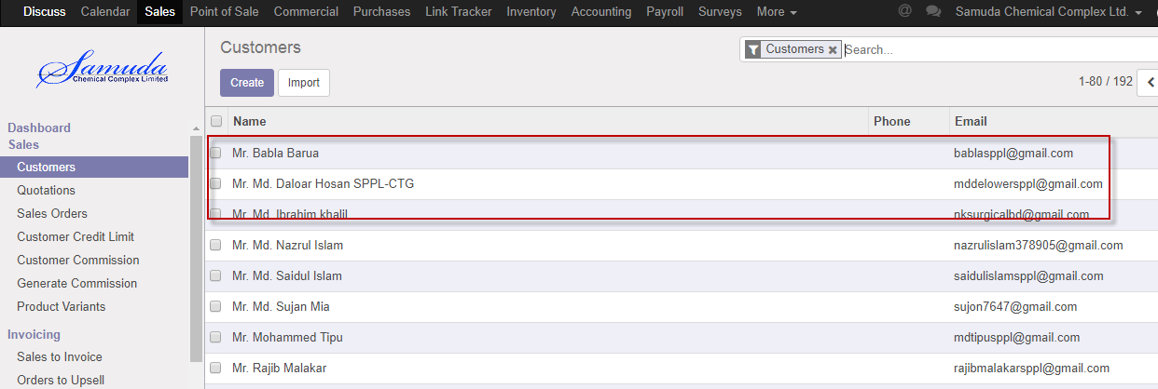

Figure: Customer List view

We need to set the following:-

N**ame**: Enter a customer name.

**Job position:** Enter job position.

**Address:** Enter address.

**Phone:** Enter Phone.

**Mobile:** Enter mobile number.

**Email:** Enter email.

**Tags:** Enter tags.

After entering all information click **Save**.

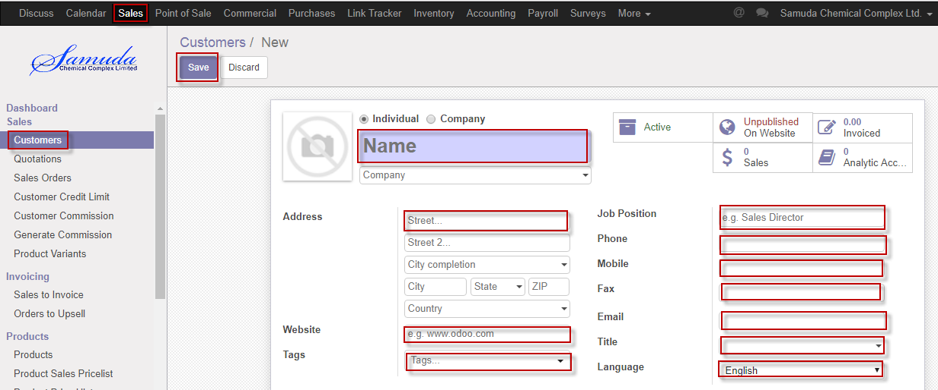

Figure: Create a customer

# 3. Products

Samuda ERP system has two types of product: Sales product, Purchase product.

Sales product will be created by Sales department & on the other hand Purchase product will be created by Purchase department.

## 3.1 Product creation by Product Manager

Product will be created/Edited by sales Product Manager.

Product Manager can create product using the menu **Sales ‣ products** and click **Create.**

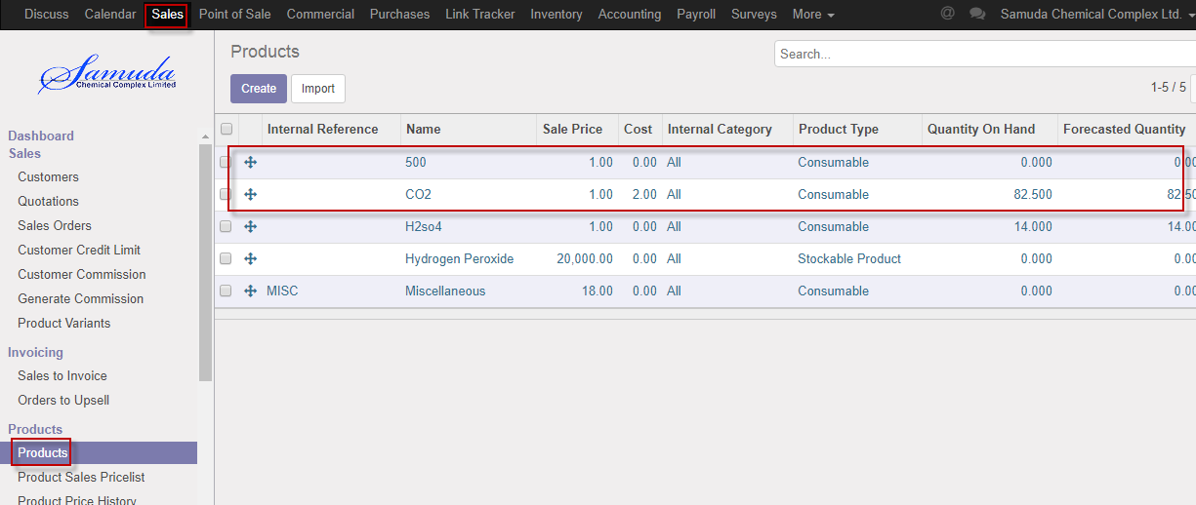

Figure: Products List view

We need to set the following:-

**Product name**: Enter a product name.

**Internal reference:** Select internal reference.

**Internal category:** Select internal category.

**Company:** select Company.

**Can be sold:** Checked.

**Can be purchased:** Unchecked.

**Product variants:** Variants of products should be set using this tab.

**UoM:** Set UoM as MT.

After entering all information click **Save**.

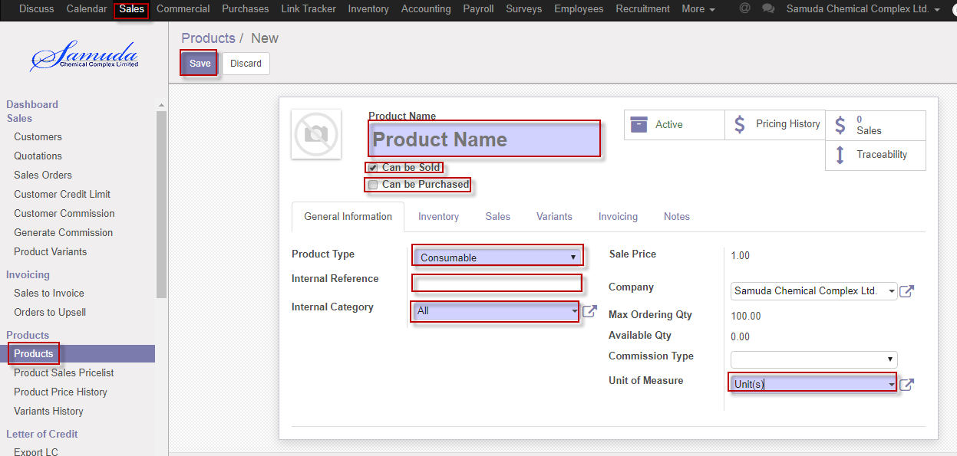

Figure: Create a products

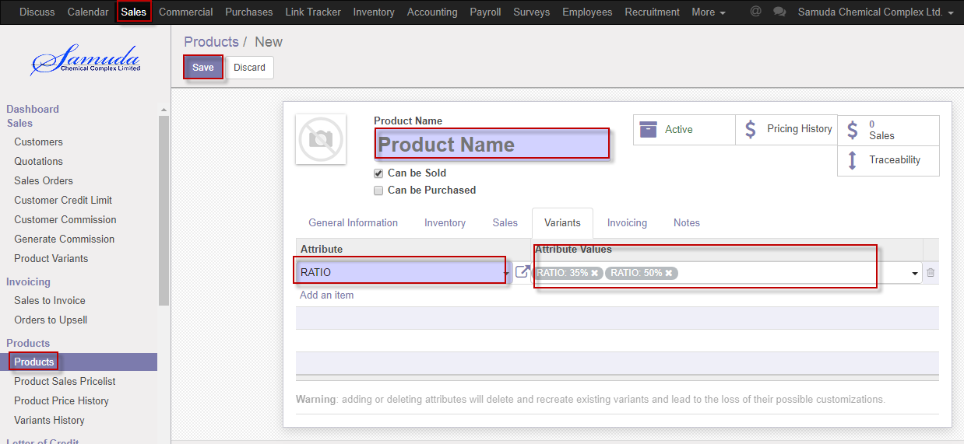

Figure: Create a variants.

# 4. Customer credit limit

Customer credit limit is the maximum amount of credit that a financial institution or other lender will extend to a debtor for a particular line of credit (sometimes called a credit line, line of credit, or a trade line.

If exceed credit limit during Sales order then Second level approval require.

If (Receivable amount +sales order amount) is greater than credit limit then will go second level approval.

## 4.1 Create customer credit limit by Sales Executive/Head of sales

Sales Executive will be created/Edit by customer credit limit.

We can create Customer using the menu **sales ‣ Customer credit limit** and click **Create.**

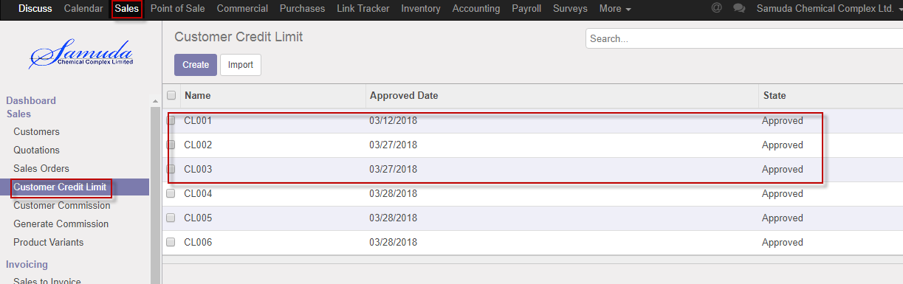

Figure: Customer credit limit List view

We need to set the following:-

**Description**: Enter a description.

**Credit limit**: Enter credit limit.

**Days:** Enter days.

**Customer:** Select customer.

**Confirm:** press Confirm button.

After entering all information click **Save**.

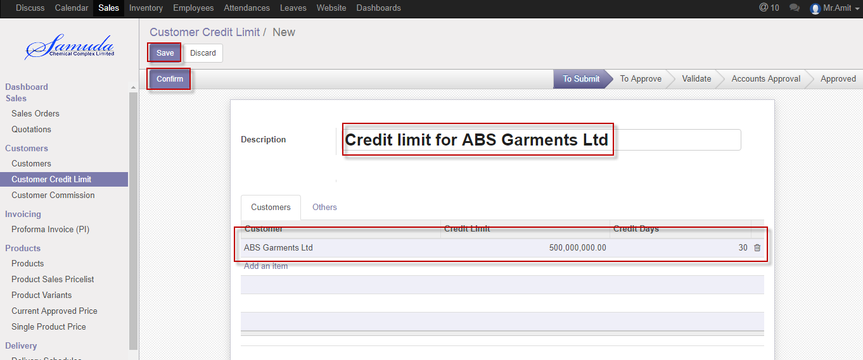

Figure: Create customer credit limit

## 4.2 Customer credit limit approval by Head of Sales

After apply the customer Credit limit head of sales will get the notification. He/she can update limit before approval.

To see the customer credit limit request use the menu **Sales ‣ Customer credit limit**

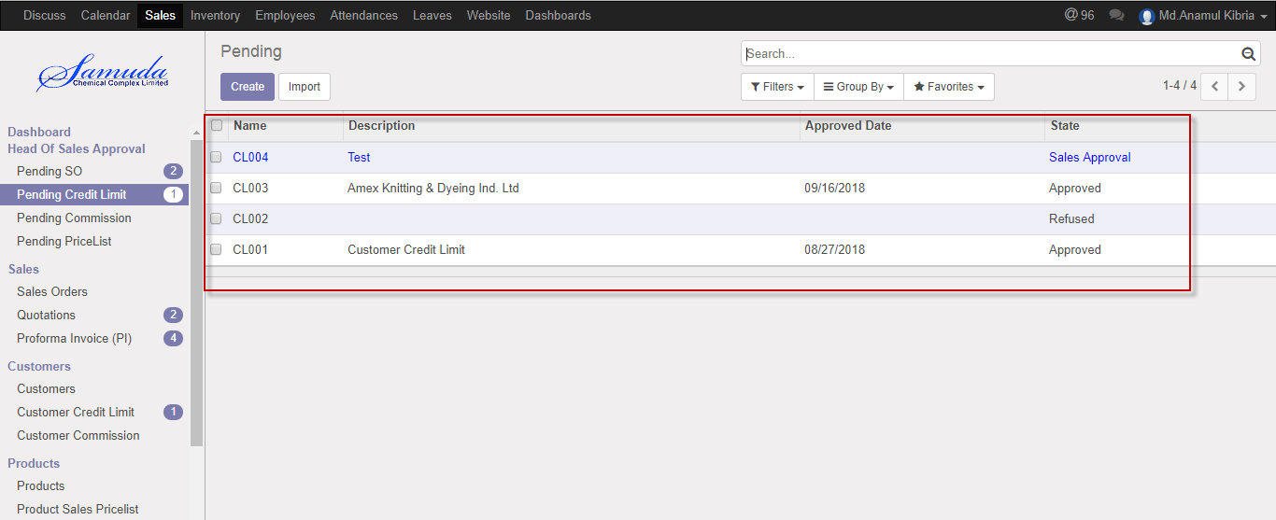

Figure: Customer credit limit list view

Head of Sales can approve customer credit limit. Head of sales approve the request by click on **Approve** button 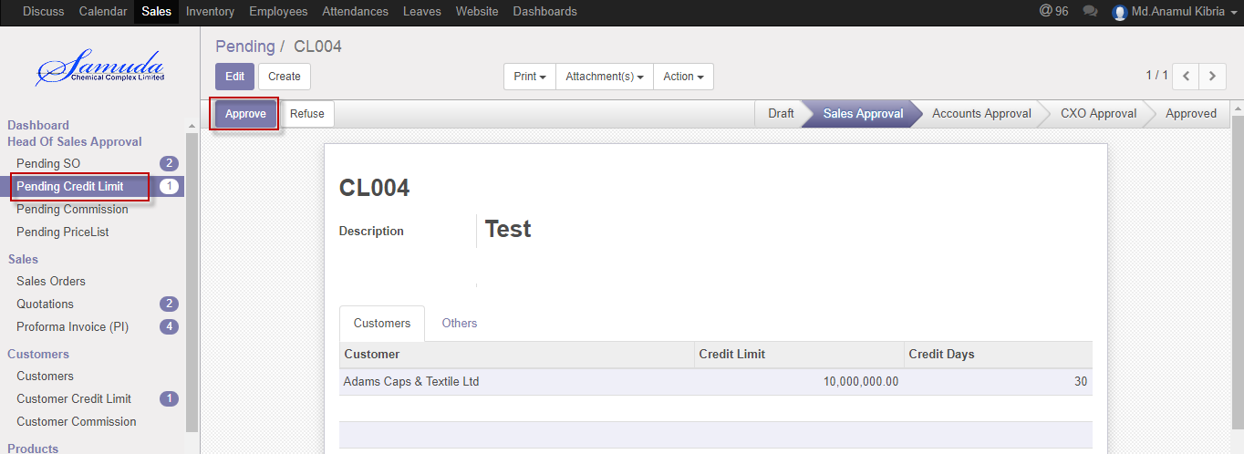

Figure: Customer credit limit approval

Head of sales can refuse customer credit limit by click **Refuse** Button.

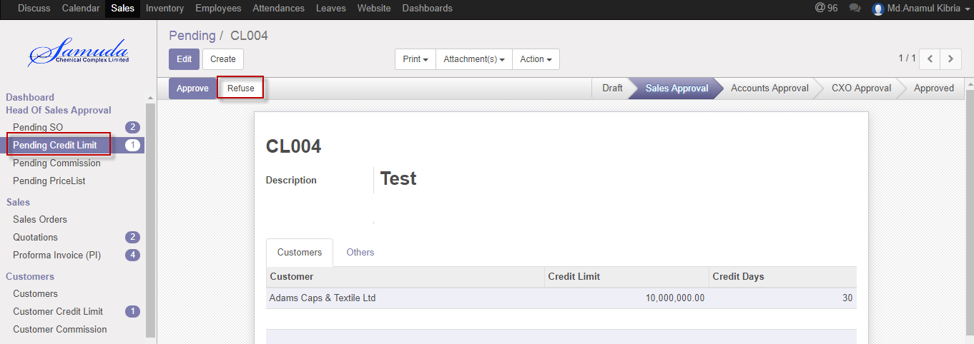Figure: Customer credit limit Refuse

## 4.3 Customer credit limit Validate by Head of accounts

After approve the customer Credit limit by head of sales, head of accounts will get the notification. He/she can validate/refuse the customer credit limit.

To see the customer credit limit request use the menu **Sales ‣ Customer credit limit**

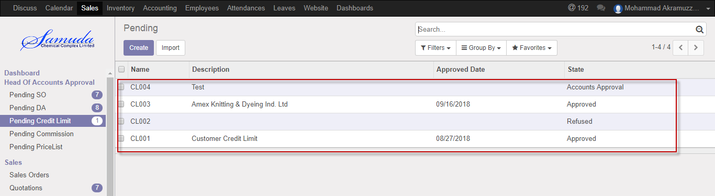

Figure: Customer credit limit list view

Head of accounts can validate customer credit limit. Head of accounts approve the request by click on **Validate** button 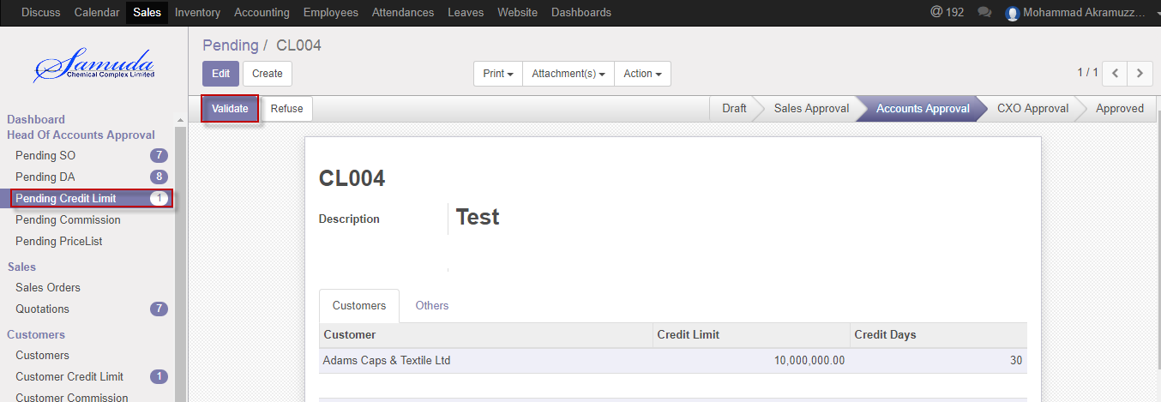

Figure: Customer credit limit Validate

Head of accounts can refuse customer credit limit by click **Refuse** Button.

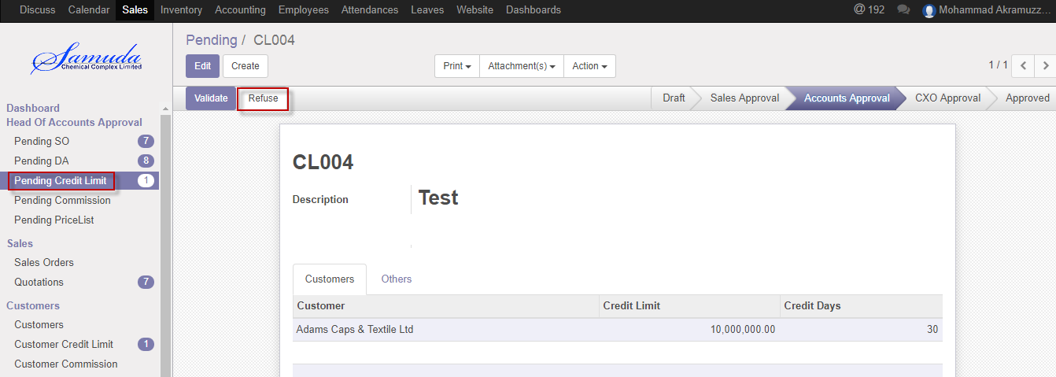 Figure: Customercredit limit Refuse

## 4.4 Customer credit limit approve by CXO

After approve the customer Credit limit by head of accounts, CXO will get the notification. He/she can approve the customer credit limit.

To see the customer credit limit request use the menu **Sales ‣ Customer credit limit**

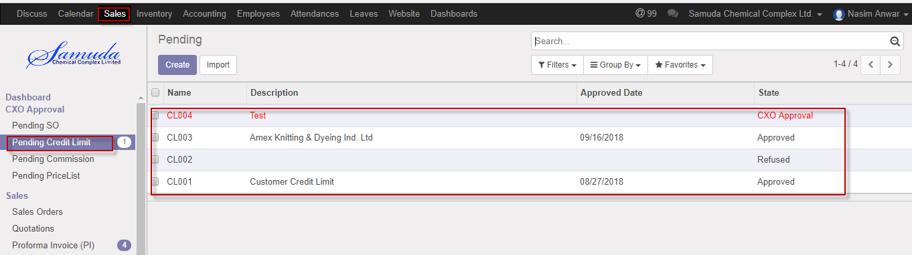

Figure: Customer credit limit list view

CXO can approve customer credit limit. CXO approve the request by click on **Approve** button 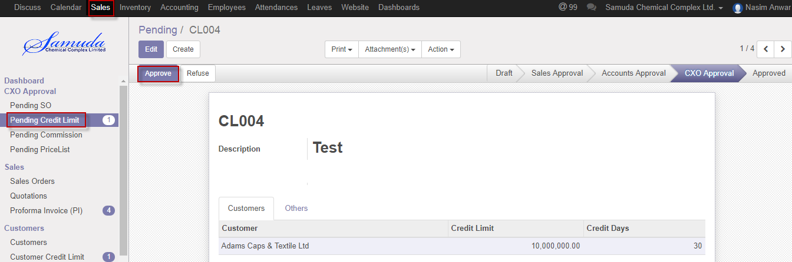

Figure: Customer credit limit Approval

CXO can refuse customer credit limit by click **Refuse** Button.

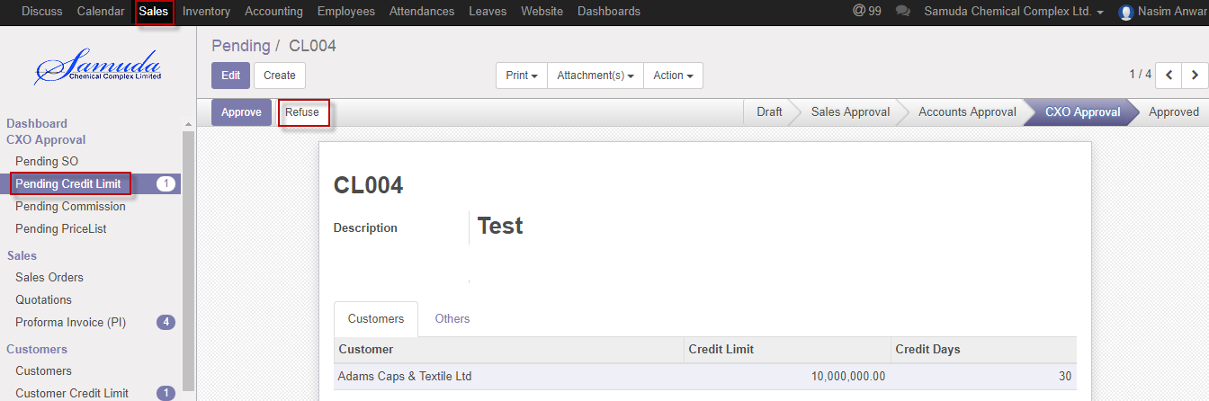 Figure: Customercredit limit Refuse

# 5. Customer Commission

Customer commission request will be initiated by Sales department for example Sales Executive/Head of Sales. It will then wait for the first level approval from Head of Accounts. After the first level approval it will then wait for the second/final level of approval from Management. The request can be rejected from both the approval layers. Customer commission will be set by two types Percentage wise and State value. Commission type if customer then will be percentage wise. And if by product then will be state value.

## 5.1 Create customer commission by Sales executive/Head of sales

Customer commission will be created/Edit by Sales executive/Head of sales

We can create customer commission using the menu **Sales ‣ Customer commission** and click **Create.**

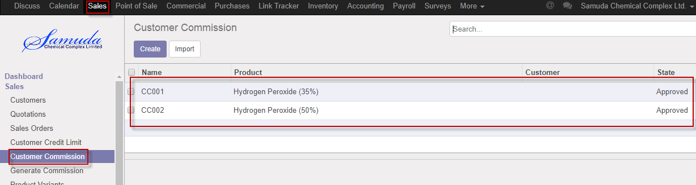

Figure: Customer commission List view

We need to set the following:-

**Commission type**: Select commission type.

**Product:** Select product.

**Customer:** Select customer.

**Value:** Enter new value.

After entering all information click **Save & confirm**.

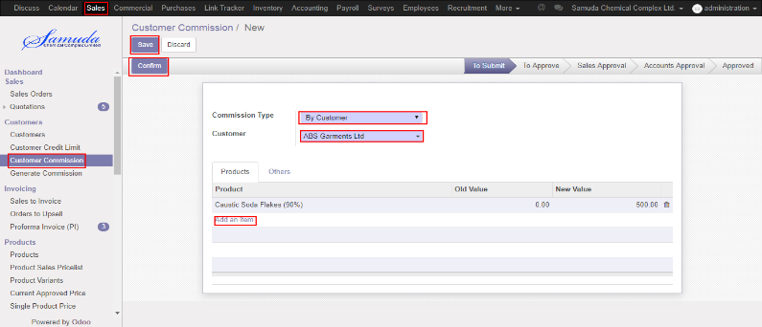

Figure: Create customer commission

## 5.2 Customer commission approval by Head of Sales

After apply the customer commission head of Sales will get the notification. He/she can update commission before approval.

To see the customer commission request use the menu **Sales ‣ Customer commission**

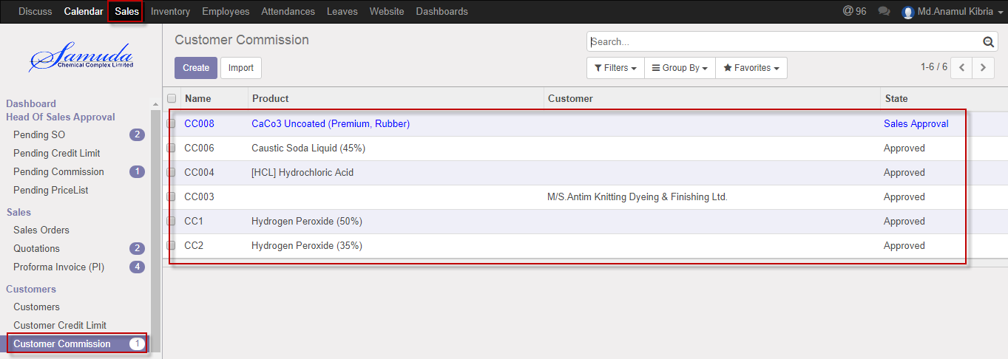

Figure: Customer commission list view

Head of sales can approve customer commission. Head of sales approve the request by click on **Approve** button 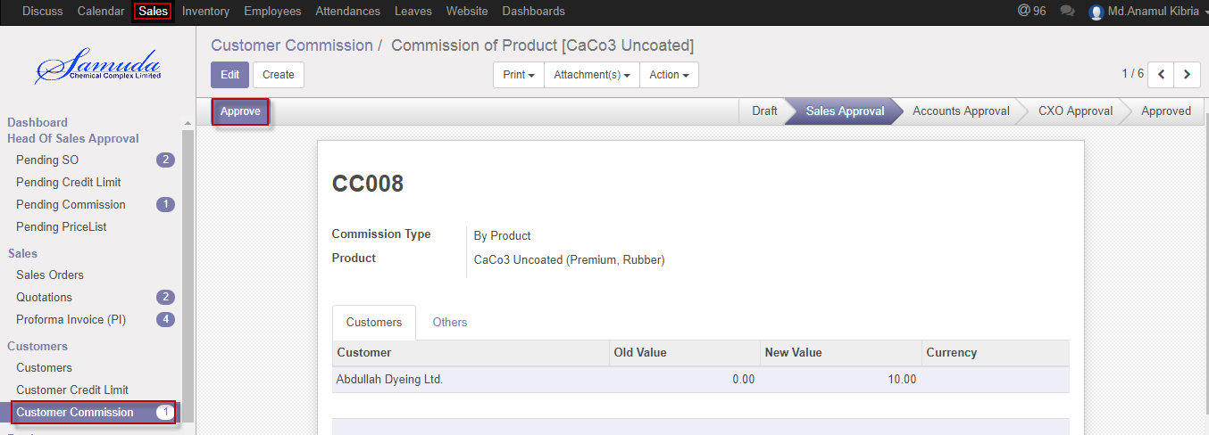

Figure: Customer commission approval

## 5.3 Customer commission Validate by Head of accounts

After approve the customer commission by head of sales, head of accounts will get the notification. He/she can validate/refuse the customer commission.

To see the customer commission request use the menu **Sales ‣ Customer commission**

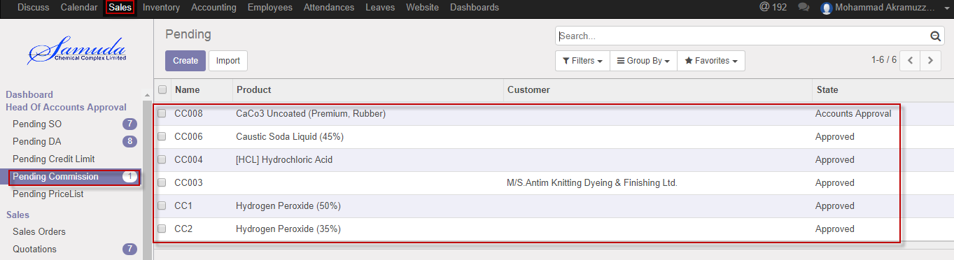

Figure: Customer commission list view

Head of accounts can validate customer commission. Head of accounts validate the request by click on **Validate** button 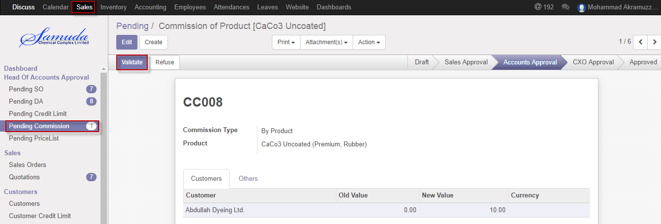

Figure: Customer commission Validate

Head of accounts can refuse customer commission by click **Refuse** Button.

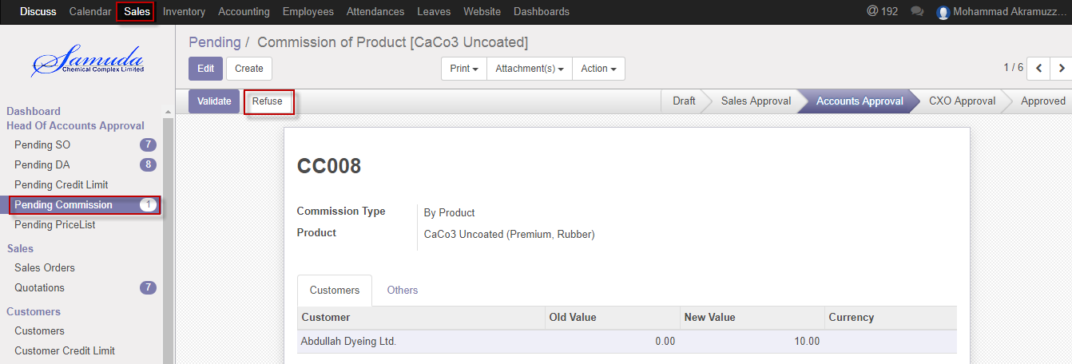 Figure: Customercommission Refuse

## 5.4 Customer commission approval by CXO

After approve the customer commission by head of accounts, CXO will get the notification. He/she can approve the Customer commission.

To see the customer commission request use the menu **Sales ‣ Customer commission**

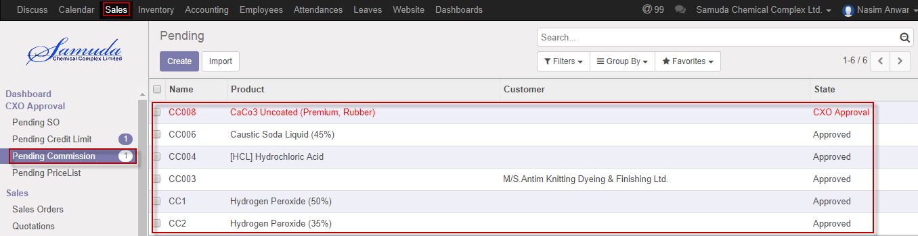

Figure: Customer commission list view

CXO can approve customer commission. CXO approve the request by click on **Approve** button 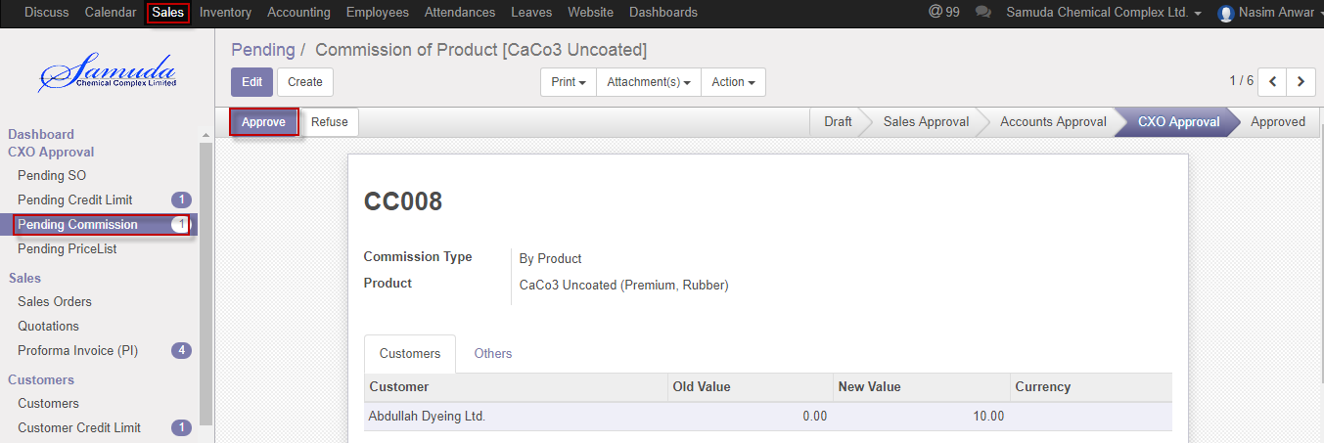

Figure: Customer commission approval

CXO can refuse customer commission by click **Refuse** Button.

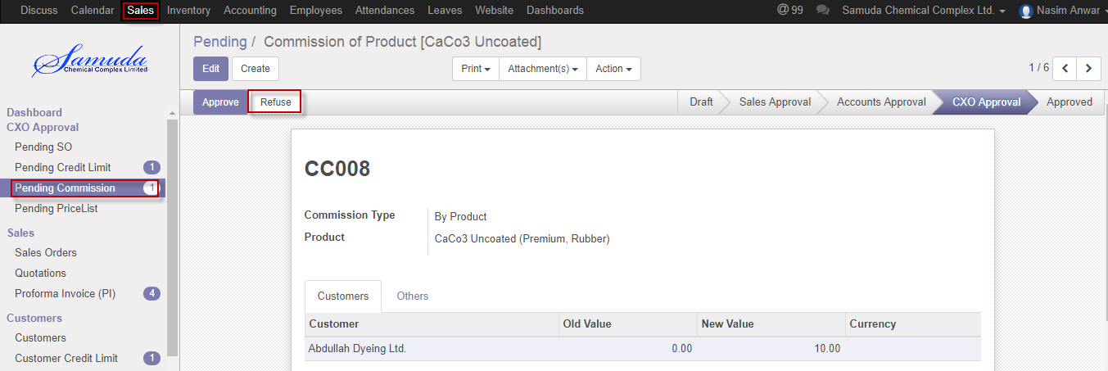 Figure: Customercommission Refuse

# 6. Product Sales Pricelist

This form will introduce new product price replacing the old product price. Management user can be able to change product price & last new price should be countable & old price should have always read only. Latest price will show in product.

Product, packing mode, UoM & Currency wise will calculate in Quotation or Sales order form.

## 6.1 Create product sales pricelist by Sales executive/Head of sales

Product sales pricelist will be created/Edit by Sales executive

We can create product sales pricelist using the menu **Sales ‣ Products>>Product sales pricelist** and click **Create.**

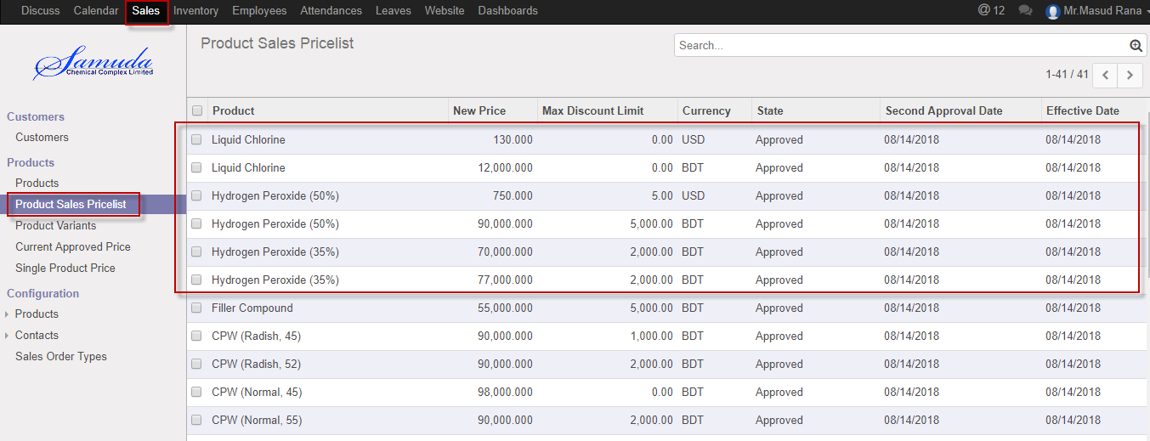

Figure: Product sales pricelist List view

We need to set the following:-

**Product**: Select product.

**Packaging Mode:** Select packaging mode.

**UoM:** Select UoM.

**Currency:** Select currency.

**New price:** Enter new price.

**Effective date:** Select effective date.

After entering all information click **Save & confirm**.

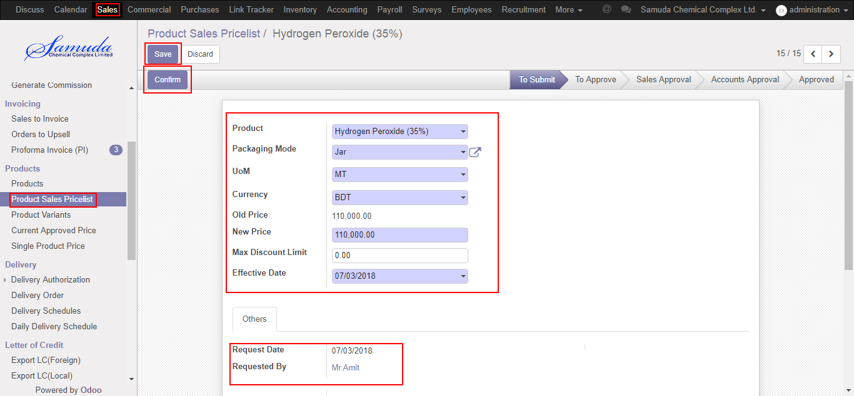

Figure: Create product sales pricelist

## 6.2 Product sales pricelist Approve by head of sales

After confirmation the product sales pricelist head of sales will get the notification. He/she can approve sales price.

To see the product sales pricelist request use the menu **Sales ‣ Products>>Product sales pricelist**

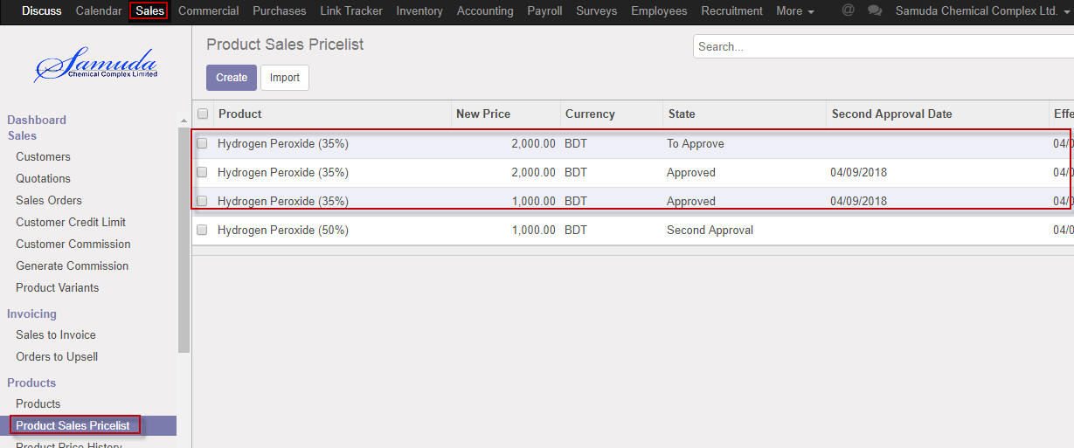

Figure: Product sales pricelist list view

Head of sales can approve product sales pricelist. Head of sales approve the request by click on **Approve** button 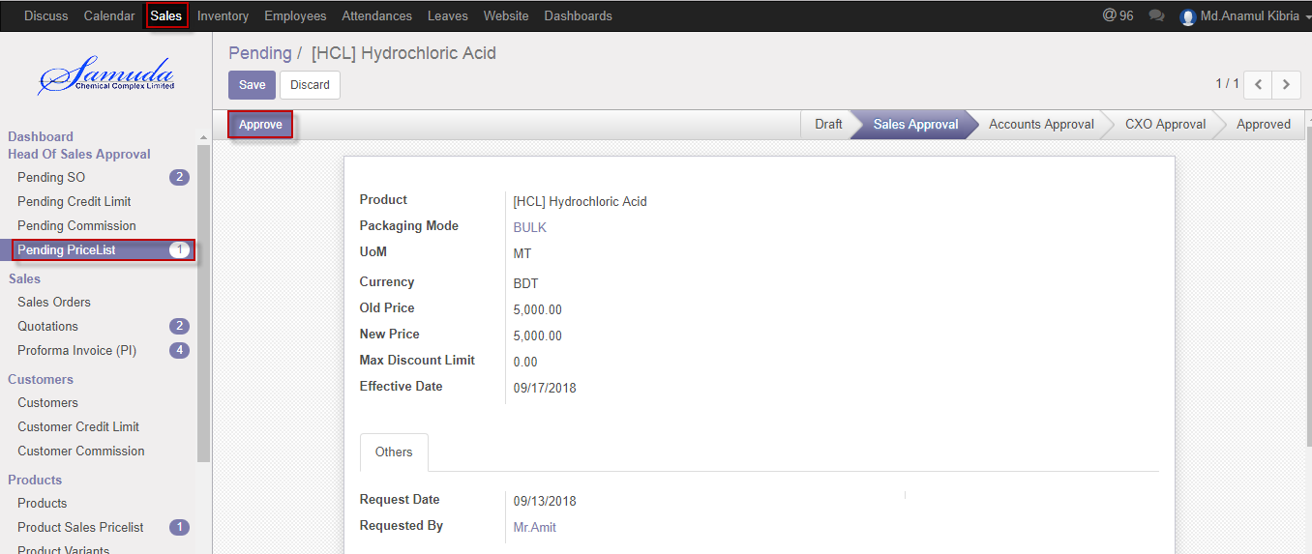

Figure: Sales pricelist Approve

## 6.3 Product sales pricelist Validate by Head of accounts

After approve the Product sales pricelist by head of sales, head of accounts will get the notification. He/she can validate/refuse the customer commission.

To see the Product sales pricelist request use the menu **Sales ‣ Product sales pricelist**

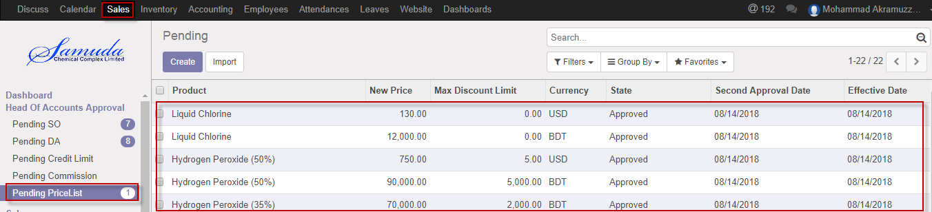

Figure: Product sales pricelist list view

Head of accounts can validate Product sales pricelist. Head of accounts validate the request by click on **Validate** button 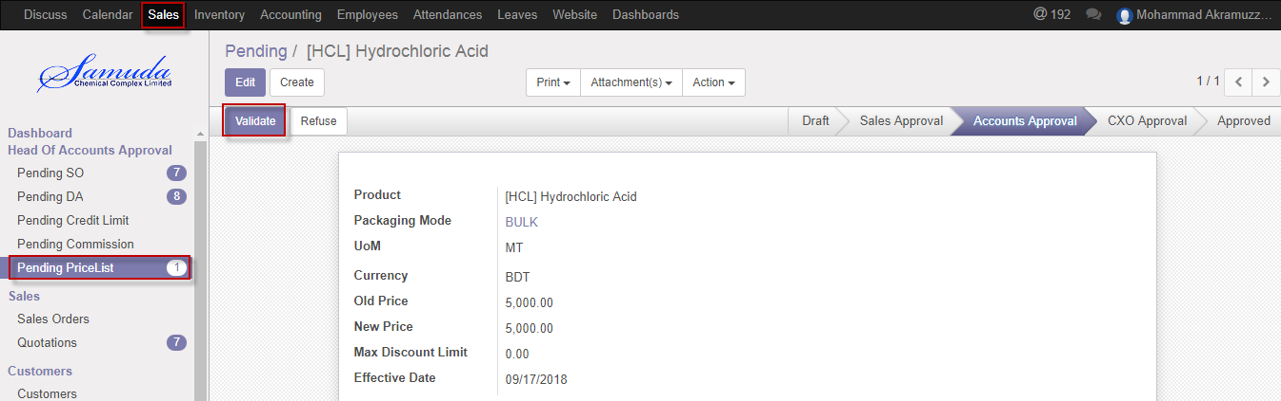

Figure: Product sales pricelist Validate

Head of accounts can refuse Product sales pricelist by click **Refuse** Button.

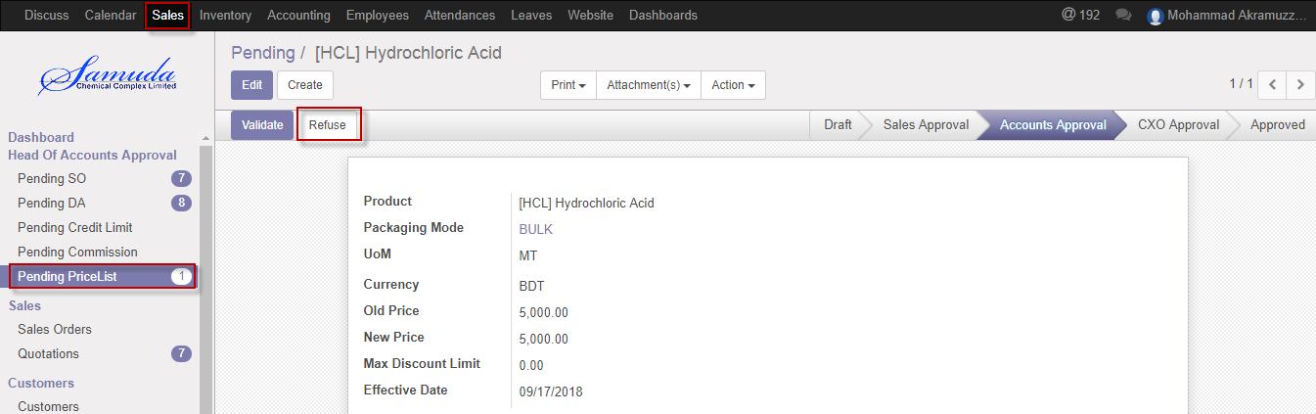 Figure: Product sales pricelist Refuse

## 6.4 Product sales pricelist Approve by CXO

After Validate the product sales pricelist head of accounts, CXO will get the notification. He/she can approve sales price.

To see the product sales pricelist request use the menu **Sales ‣ Products>>Product sales pricelist**



Figure: Product sales pricelist list view

CXO can approve product sales pricelist. CXO can approve the request by click on **Approve** button 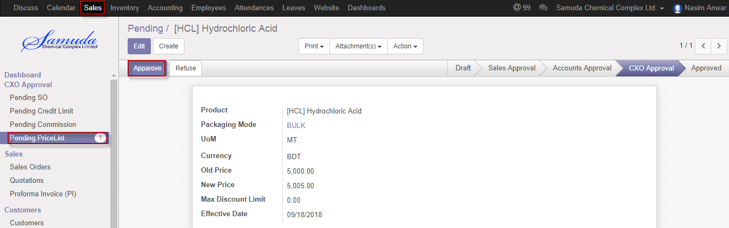

Figure: Sales pricelist Approve

CXO can refuse Product sales pricelist by click **Refuse** Button.

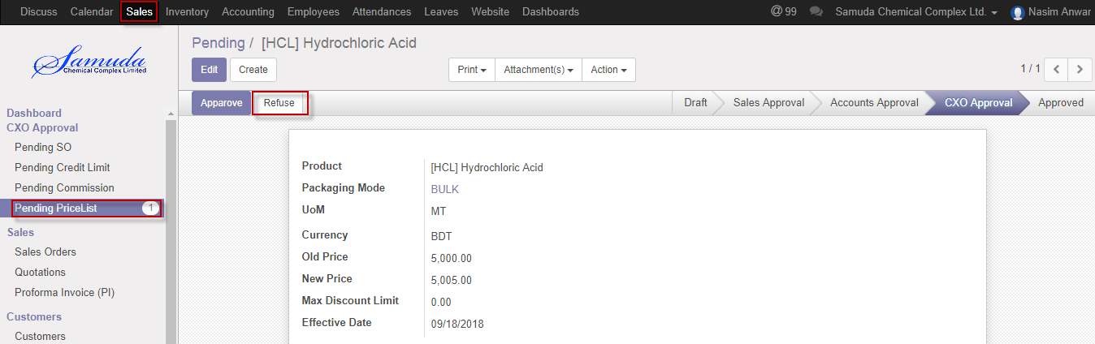 Figure: Product sales pricelist Refuse

# 7. Variant history

Everyday 6pm will auto update a scheduler then latest product price history will come auto. Product prices will be automatically updated by a schedules every day at 6PM.

## 7.1 Variant history view by Sales user

These prices will be loaded when a sales order is created.

We can view Variant history using the menu **Sales ‣Current Approved Price**

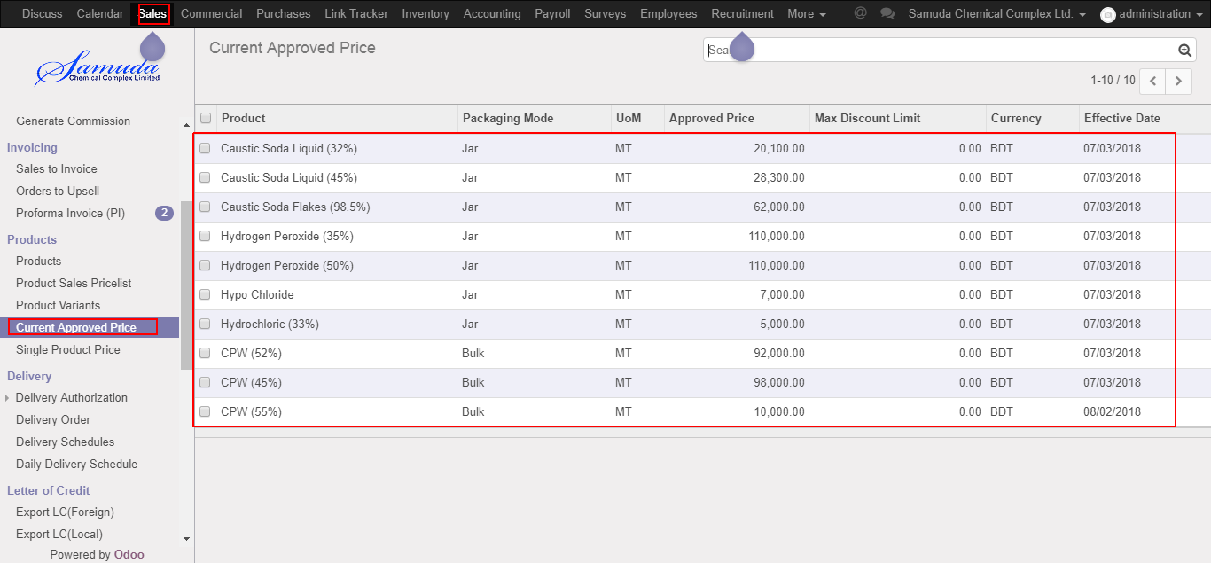

Figure: Variant history view

# 8. Generate commission

Accounts user will generate commission. After generate commission Customer will get commission up to date.

## 8.1 Create Generate commission by Accounts executive/Head of accounts

Generate commission will be created/Edit by Accounts executive/Head of accounts

We can create Generate commission using the menu **Sales ‣ Customer>>Generate commission** and click **Create.**

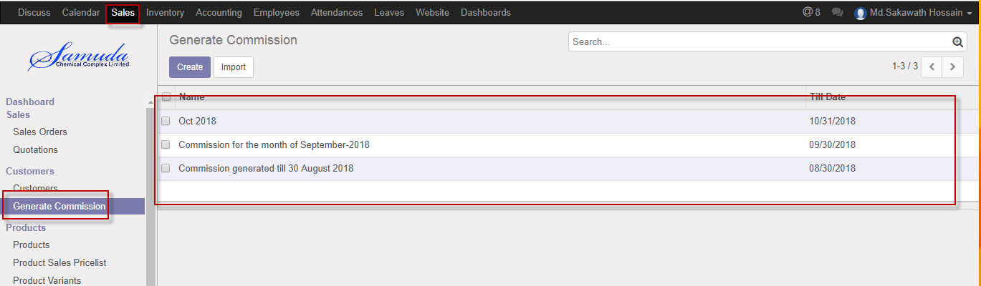

Figure: Generate commission List view

We need to set the following:-

**Title**: Enter a commission title name.

**Till date:** Select a date.

**Customer:** Customer will come auto after click generate button.

**Invoiced amount:** Invoice amount will come auto after click generate button.

**Commission amount:** Commission amount will come auto after click generate button.

After entering all information click **Generate & Save** button.

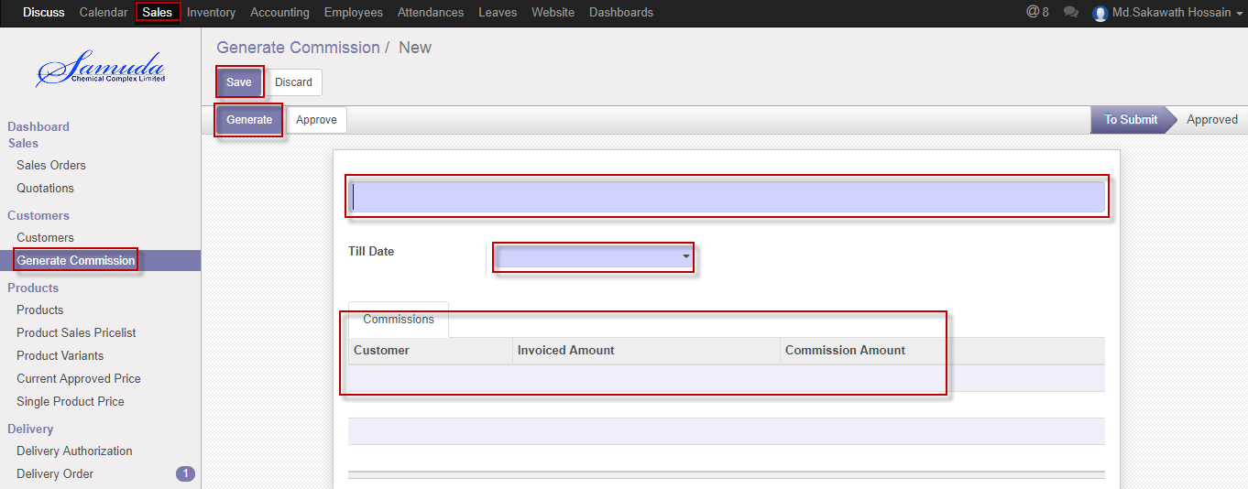

Figure: Create Generate commission

## 8.2 Generate commission Approve by Accounts executive/Head of accounts

To see the Generate commission use the menu **Sales ‣ Customer >>Generate commission**



Figure: Generate commission list view

Accounts executive/Head of accounts can approve generate commission. Accounts executive/Head of accounts can approve the request by click on **Approve** button 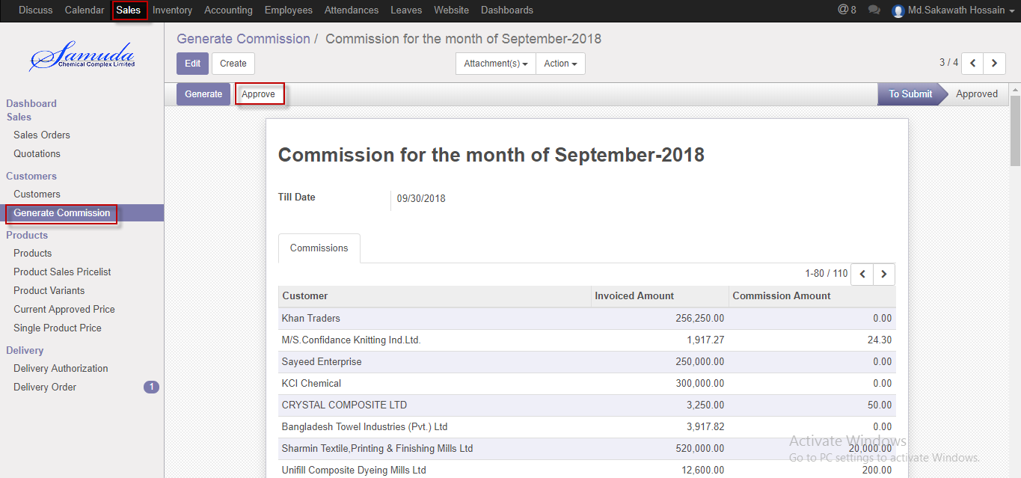

Figure: Generate commission Approve

# 9. Proforma Invoice

## 9.1 Create Proforma Invoice by Sales executive

We can view Proforma Invoice using the menu **Sales ‣** **Proforma Invoice**

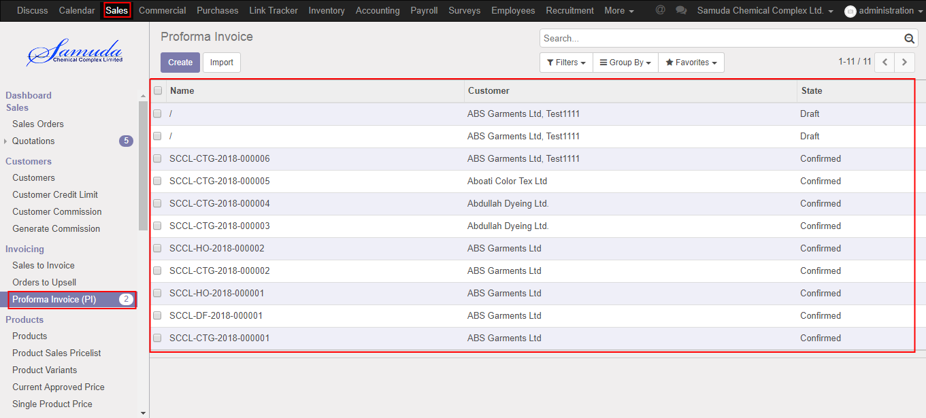

Figure: Proforma Invoice tree view

We need to set the following:-

**Beneficiary**: Select beneficiary.

**Invoice date:** Select invoice date.

**Select Advising Bank:** Select advising Bank.

**Customer:** Select Customer.

**Transport type:** Enter transport type.

After entering all information click **Save & Confirm**

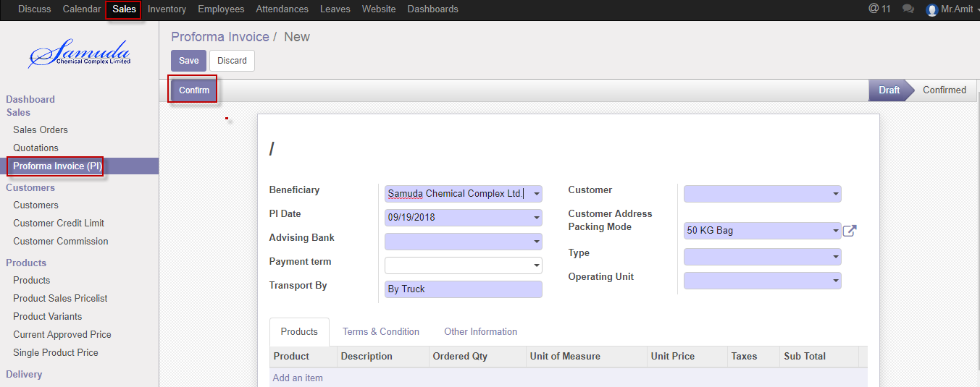

Figure: Create Proforma Invoice

# 10. Sales Order

The process start from getting an order request from a customer to sales executive. Based on the business nature, Samuda practices three types of Sales Order. This three types of sales order will be created from Sales order type form.

1. Cash

2. Credit Sales

3. LC

## 10.1 Create sales order by Sales executive

Sales order will be created/Edit by Sales executive

We can create sales order using the menu **Sales ‣ Sales order** and click **Create.**

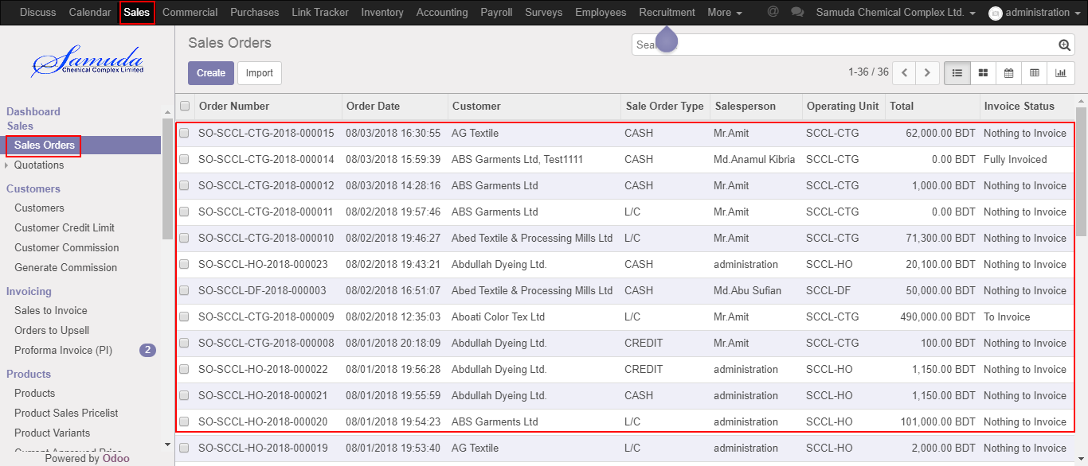

Figure: Sales order List view

We need to set the following:-

**Customer**: Select customer.

**Order date:** Select order date.

**Expiration date:** Select expiration date.

**Type:** Select type.

**Packing mode:** Select packing mode.

**Sales Channel:** Select sales channel.

**Order line:** Add order line.

After entering all information click **Save & Submit**.

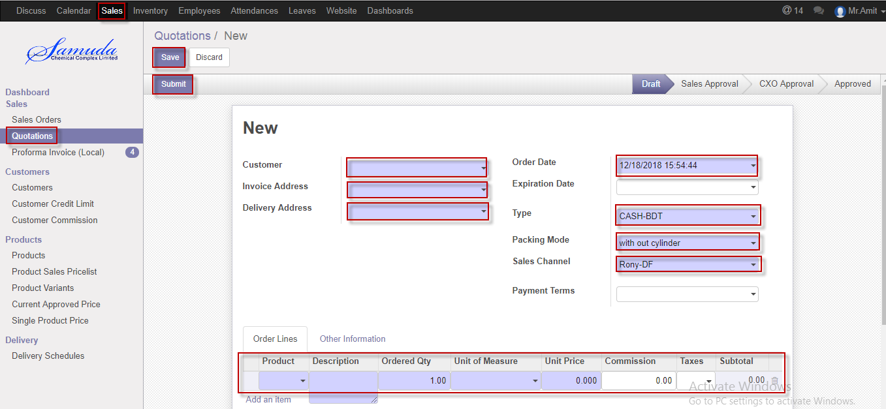

Figure: Create sales order

## 10.2 Sales order approval by head of sales

Head of sales will approve first approval. If unit price & commission no change then it will done state.

If unit price or commission change then it will go for Management approval.

After apply the sales order head of sales will get the notification. He/she can update before approve.

To see the sales order request use the menu **Sales ‣ Sales order**

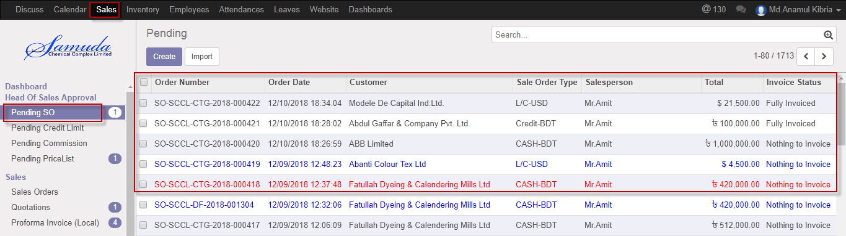

Figure: Sales order list view

Head of sales can confirm sales order. Head of sales confirm the request by click on **Confirm** button 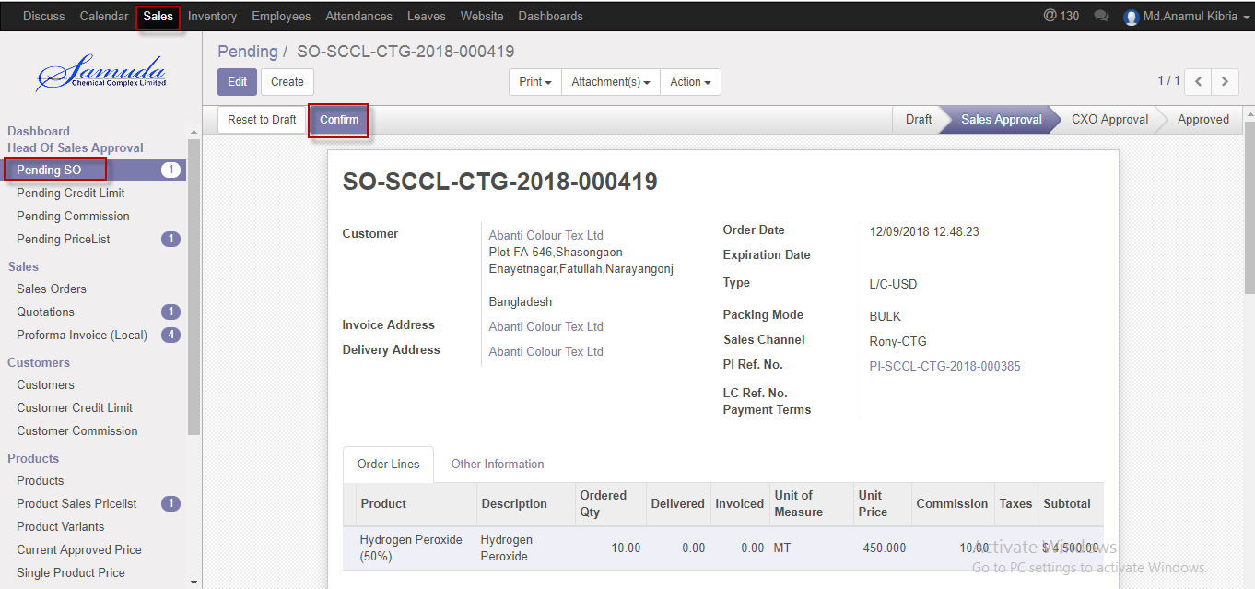

Figure: Sales order confirmed

## 10.3 Sales order validate by head of account

After creation of SO, system will check the summation of Sales Order amount, Customer's Receivable amount, and total undelivered DO qty amount for that customer, total unposted invoiced amount for that customer with Customer's Credit Limit. If positive then there is no need of Second Approval for this case and Head of Sales can give final approval of Sales Order.

After confirmation the sales order head of account will get the notification. He/she can update before approve.

To see the sales order request use the menu **Sales ‣ Sales order**

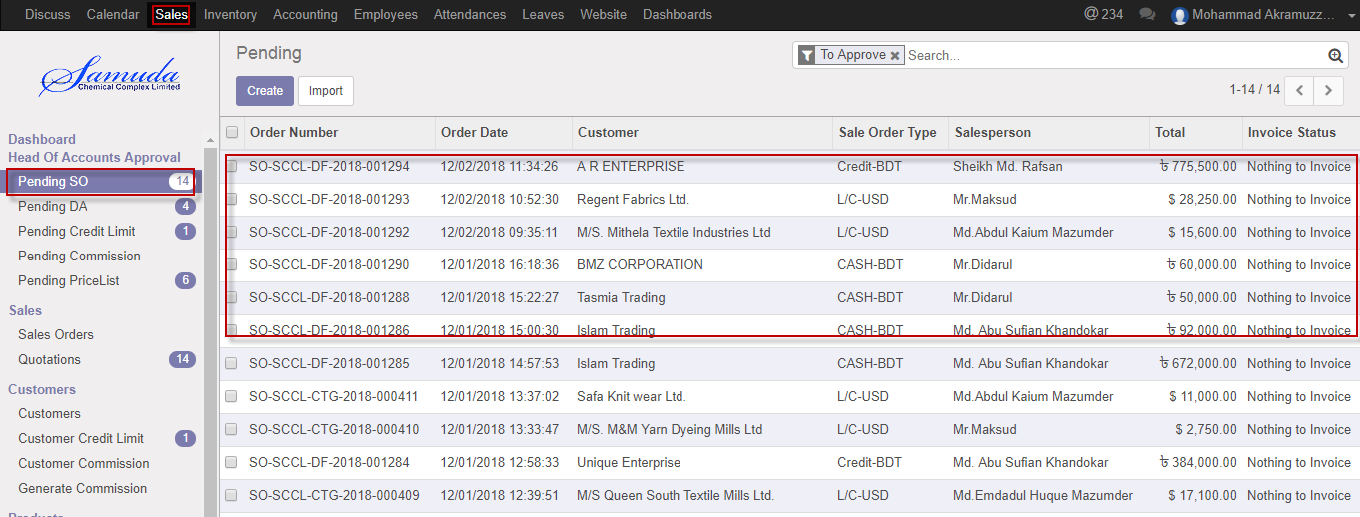

Figure: Sales order list view for validate state

Head of account can validate sales order. Head of account validate the request by click on **Validate** button 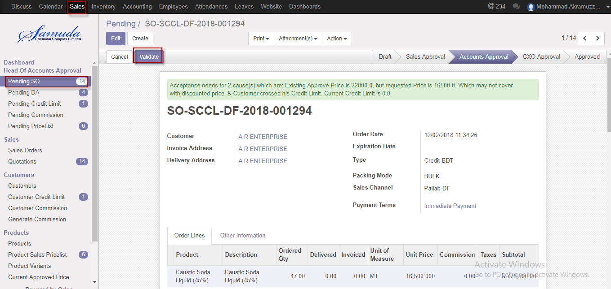

Figure: Sales order Validate

## 10.4 Sales order approve by CXO

Sales order will go CXO/Director state if Sales Order amount, Customer's Receivable amount, and total undelivered DO qty amount for that customer is bigger than credit limit.

After validate the sales order CXO will get the notification. He/she can update or cancel before approve.

To see the sales order request use the menu **Sales ‣ Sales order**

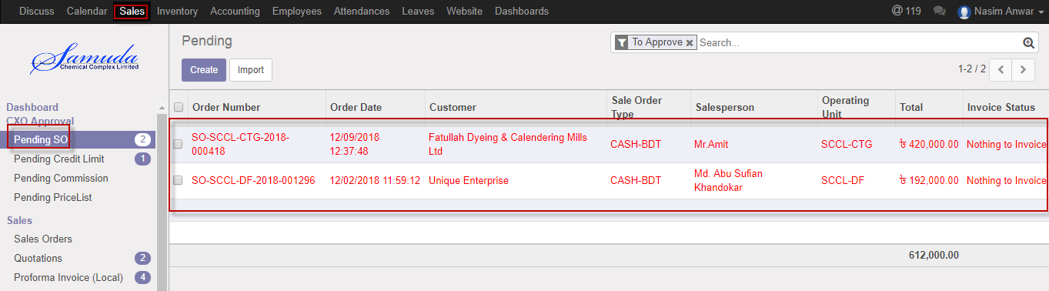

Figure: Sales order list view for approve

CXO can approve sales order. CXO approve the request by click on **Approve** button 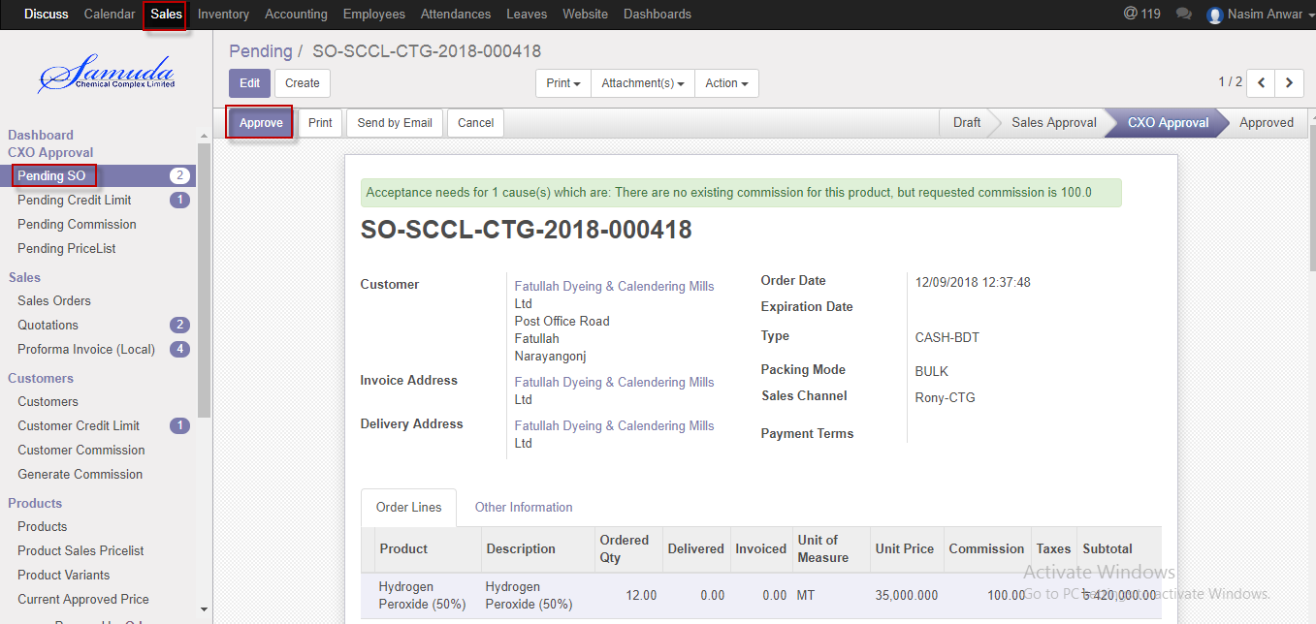

Figure: Sales order approve

Head of account & CXO is capable to cancel sales order by click **Cancel** Button.

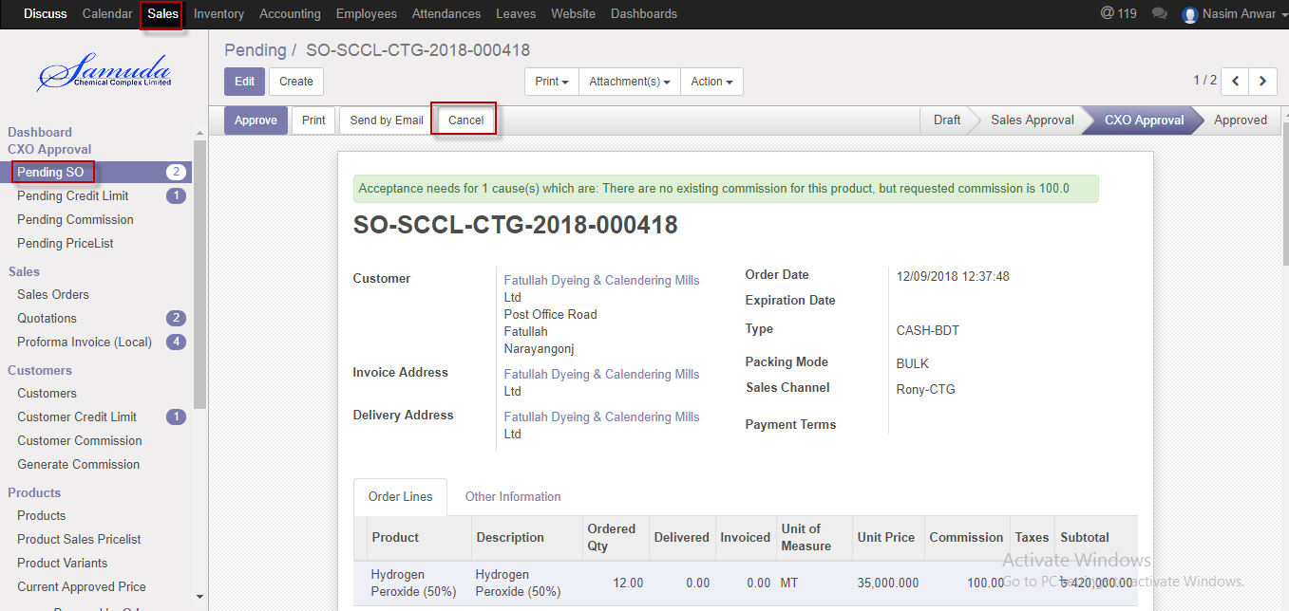

Figure: Sales order cancel

# 11. Delivery Authorization

Account Executive will create and confirm the delivery authorization. Delivery authorization will complete with in first step if Payment was done. If payment not done then will go for Head of accounts approval.

## 11.1 Create DA by Account head/Account Executive

DA will be confirmed by Account head/Account executive

We can create DA using the menu **Sales ‣ Delivery authorization** and click **confirm.**

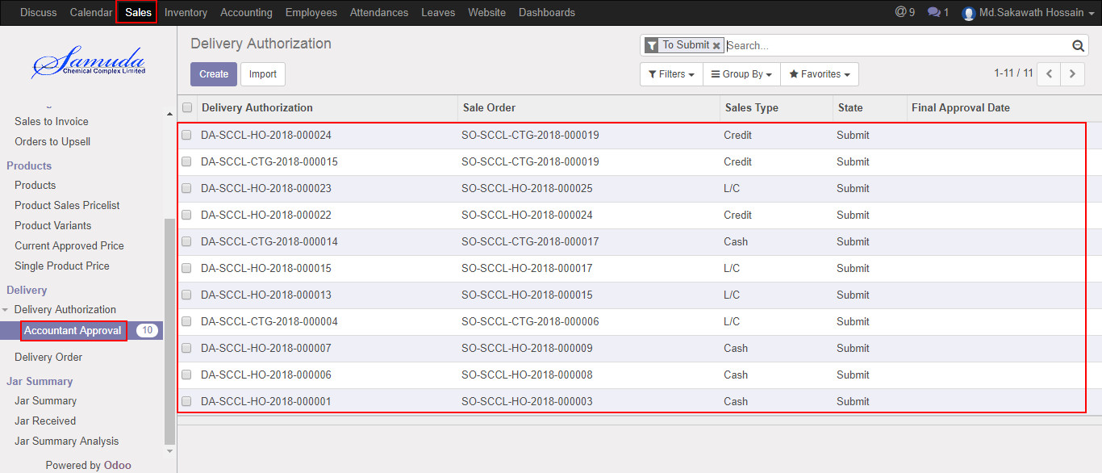

Figure: DA List view

We need to set the following:-

**Sales order**: Select sales order .All info will come auto after select sales order.

After select all information click **Save & Confirm**.

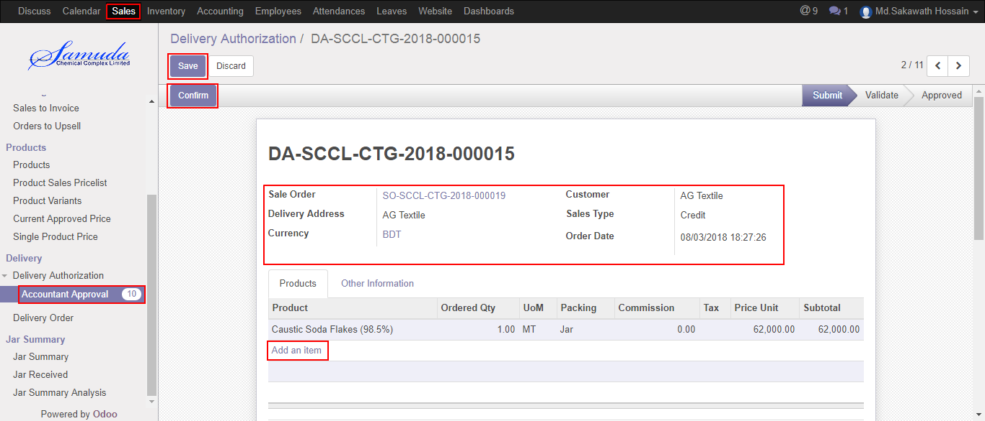

Figure: Confirm DA

## 11.2 DA Approval by Account head

Head of Sale Approval will confirm by Account head

We can create DA using the menu **Sales ‣ Head of Sale Approval**

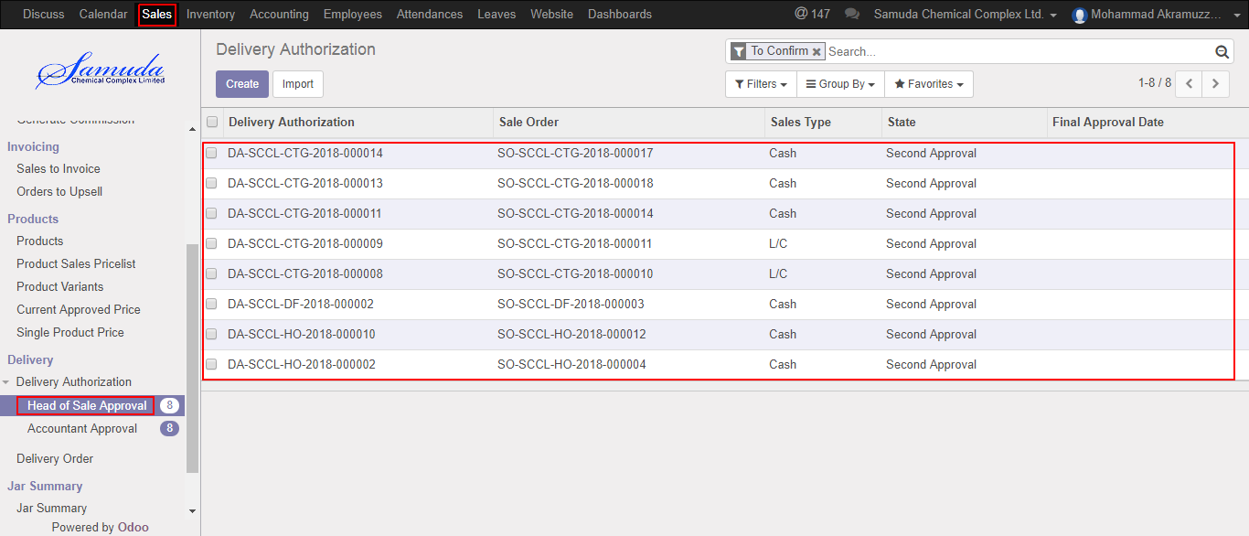

Figure: Head of Sale Approval List view

After confirm DA will ready for Validate.

After set all information click **Validate**.

Account head is capable to refuse click Refuse button

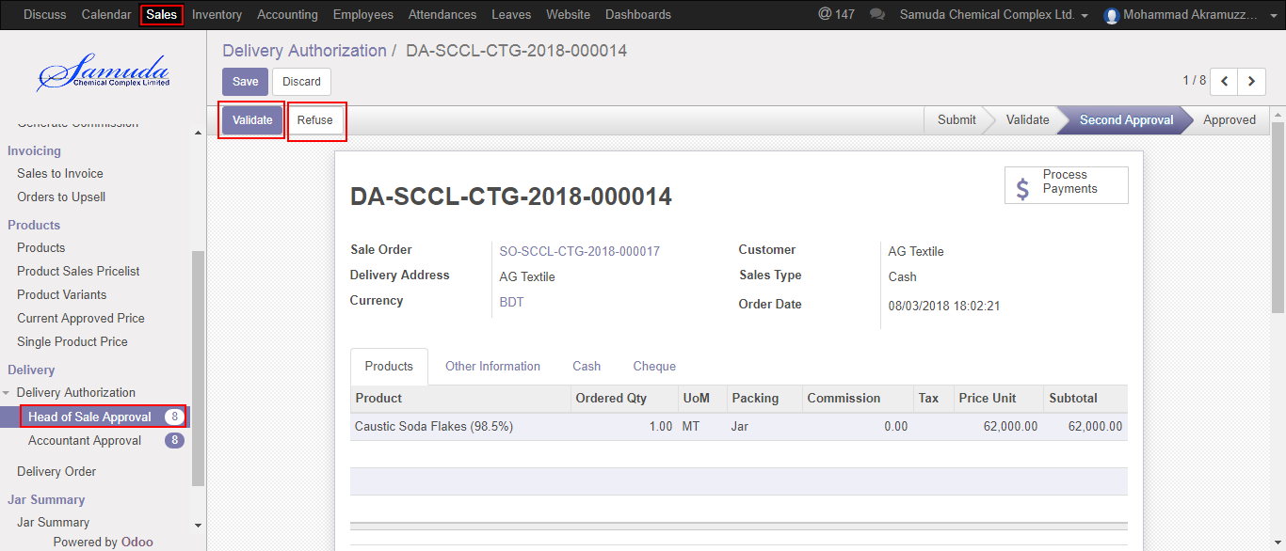

Figure: Validate & Refuse DA

# 12. Delivery Order

A delivery order before state of stock picking and after state of delivery authorization. Accounts executive or Accounts head will generate & confirm the delivery order. Delivery order will not go for Stock picking until DO confirmation. After Approved Delivery authorization Delivery order will create auto.

## 12.1 Delivery order view by accounts executive/accounts head

Delivery order will be viewed by account head.

We can view delivery order using the menu **sales ‣ Delivery** and click **Delivery order.**

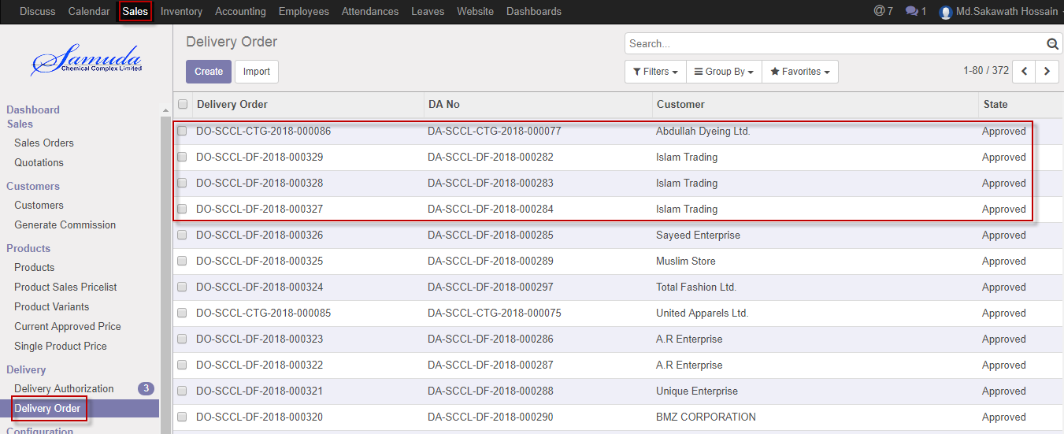

Figure: Delivery order List view

# 13. Delivery Chalan

A delivery order before state of stock picking and after state of delivery authorization. Accounts executive or Accounts head will generate & confirm the delivery order. Delivery order will not go for Stock picking until DO confirmation.

## 13.1 Delivery chalan create by delivery man

Delivery order will be created/Edit by account head.

We can create Delivery Challan using the menu **inventory** and click **To do** button.

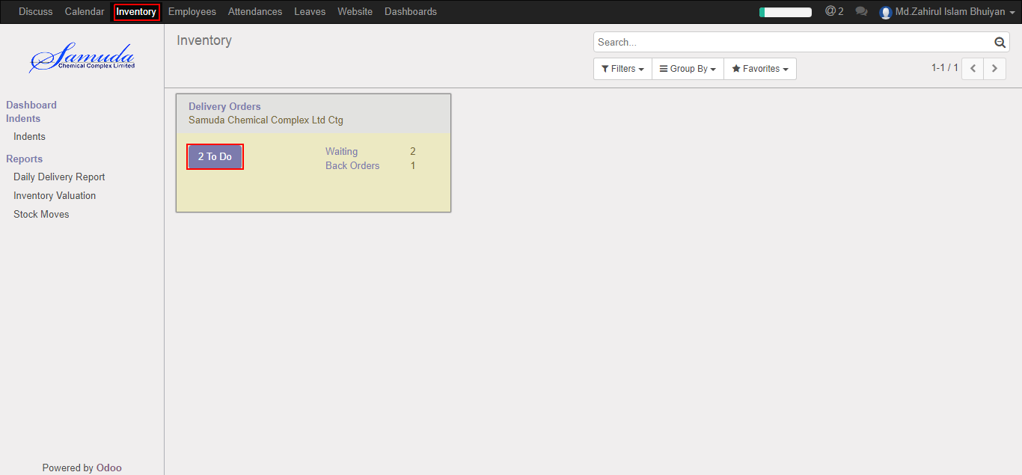

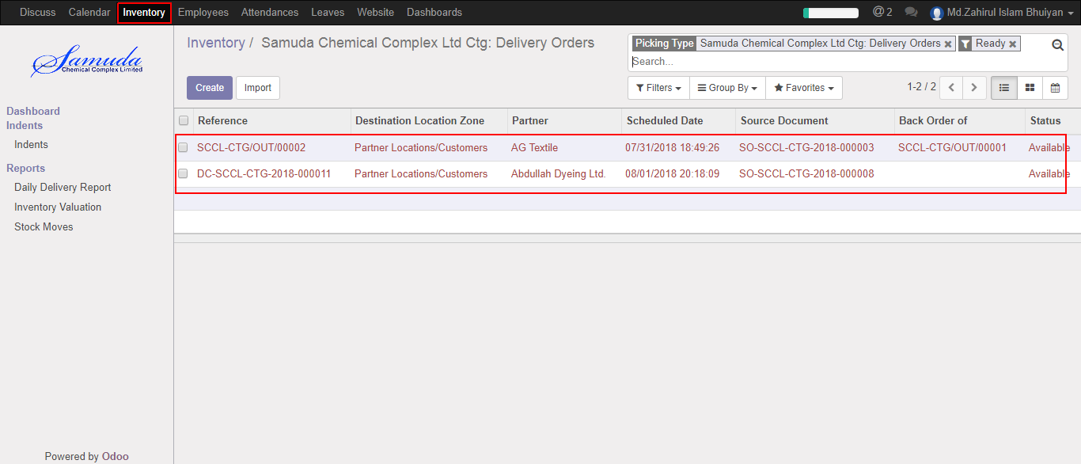

Figure: Delivery Chalan List view

We need to set the following:-

**DA no**: Select DA no. after DA no all information will come auto.

After come all information click **Save & Validate**.

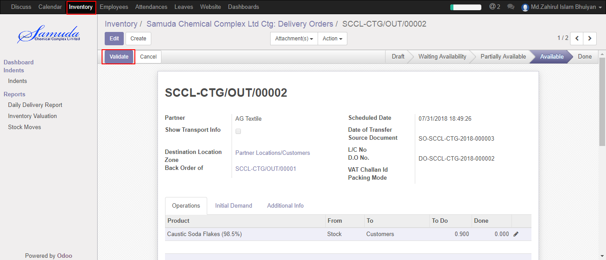

Figure: validate a delivery chalan

# 14. Delivery Schedules

Delivery schedule will create by Sales executive .After Completed Delivery Schedule Mail will go through to Delivery man with Attachment. Then Delivery man will create Delivery chalan.

## 14.1 Create Delivery Schedule by Sales executive

Delivery schedule will be created/Edit by Sales executive

We can create sales order using the menu **Sales ‣ Delivery>>Delivery Schedule** and click **Create.**

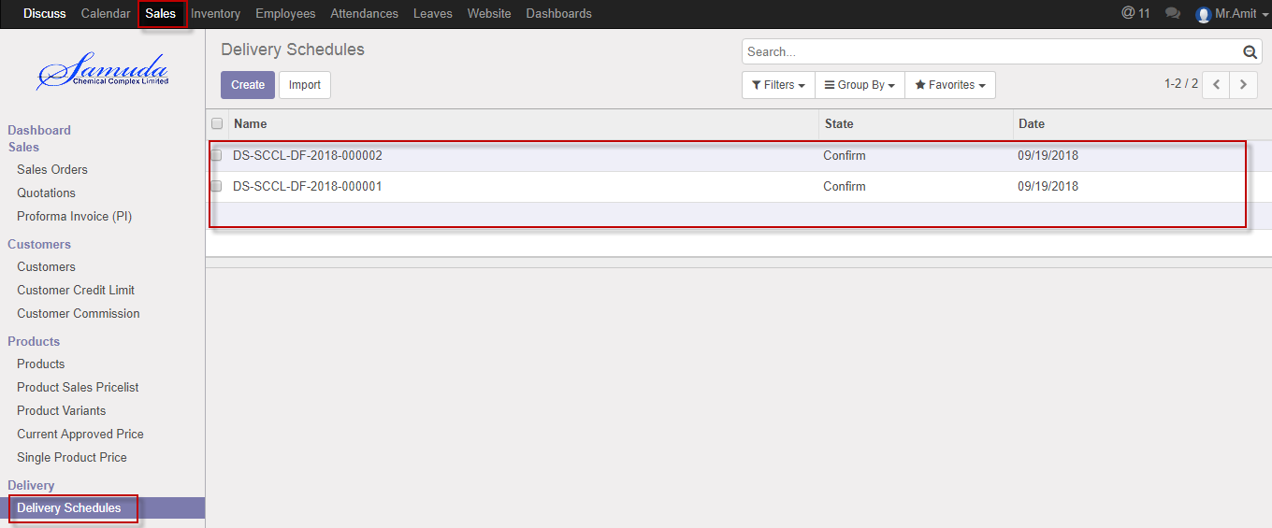

Figure: Delivery Schedule List view

We need to set the following:-

**Operating unit**: Select operating unit.

**Customer:** Select Customer.

**Pending DO:** Select pending DO.

**Order Qty:** Order Qty will come auto.

**Schedule Qty:** Enter Schedule qty.

After entering all information click **Save & Confirm**.

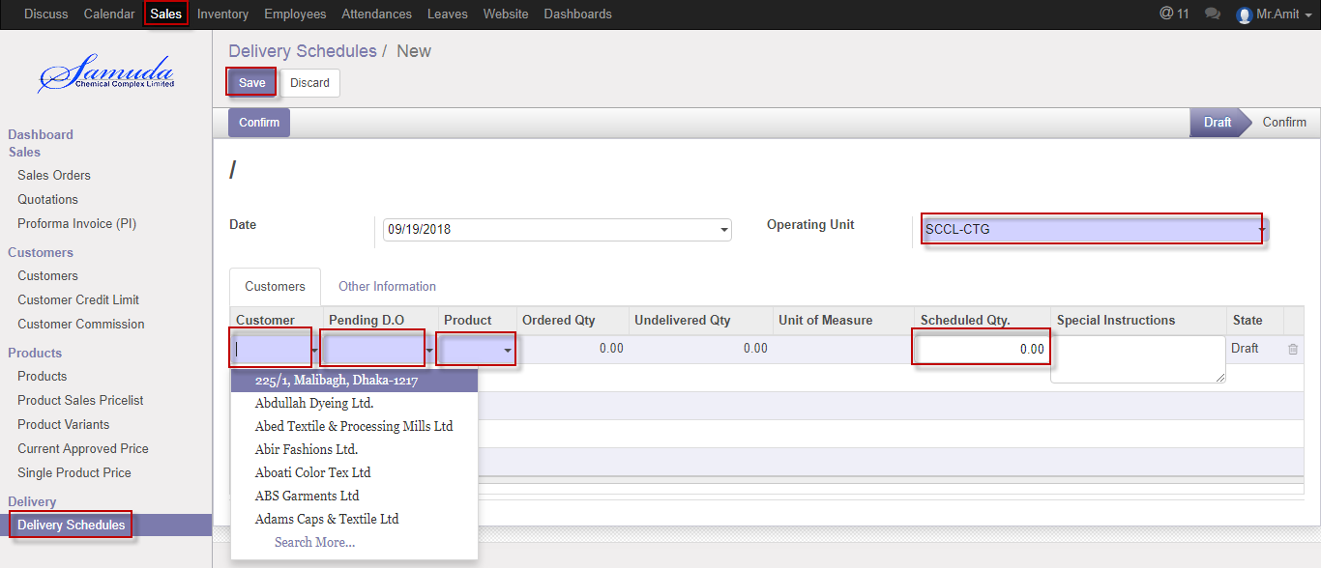

Figure: Create delivery Schedule

# 15. Delivery Instruction

Delivery Man will view delivery instruction. Then He will create Delivery challan then will click done checked.

## 15.1 Delivery instruction view by Delivery operation

Delivery order will be viewed by Delivery operation

We can view delivery Instruction using the menu **Inventory ‣ Delivery>>Delivery instruction**

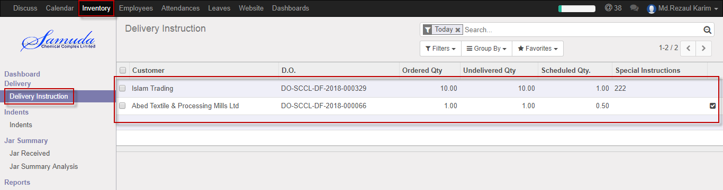

Figure: Delivery instruction List view

Delivery Man will done the instruction click Unchecked button

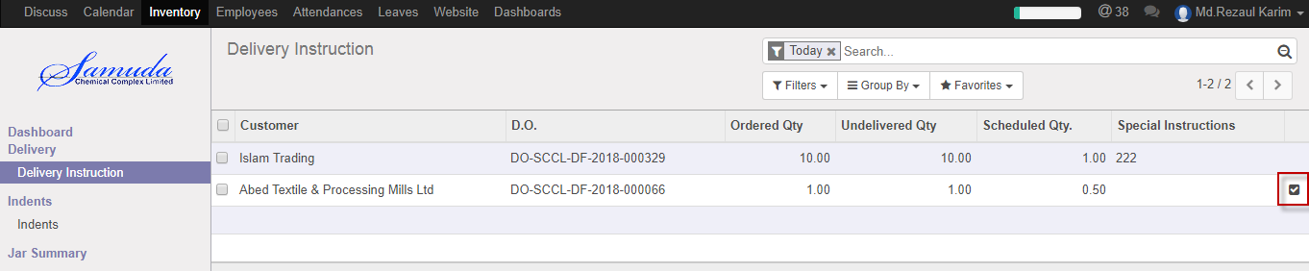

# 16. Customer Payments

Customer Payment made by Accounts executive or Head of accounts. Those SO type is Cash then related DA against will make Customer payments.

## 16.1 Create Customer payment by Accounts executive

Customer payments will be created/Edit by Accounts executive

We can create Customer payments using the menu **Accounting>>sales>>Customer payments ‣**and click **Create.**

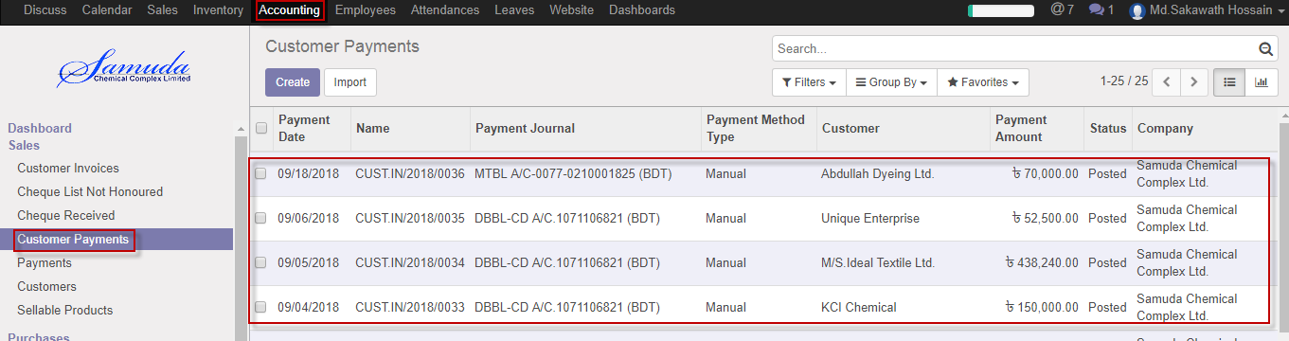

Figure: Customer Payments List view

We need to set the following:-

**Customer**: Select customer.

**Sale order:** Sale order will come auto after select customer or select manually.

**Payment journal:** Select payment journal.

**Payment date:** Select payment date.

**Payment amount:** Enter payment amount.

After entering all information click **Save & Confirm**.

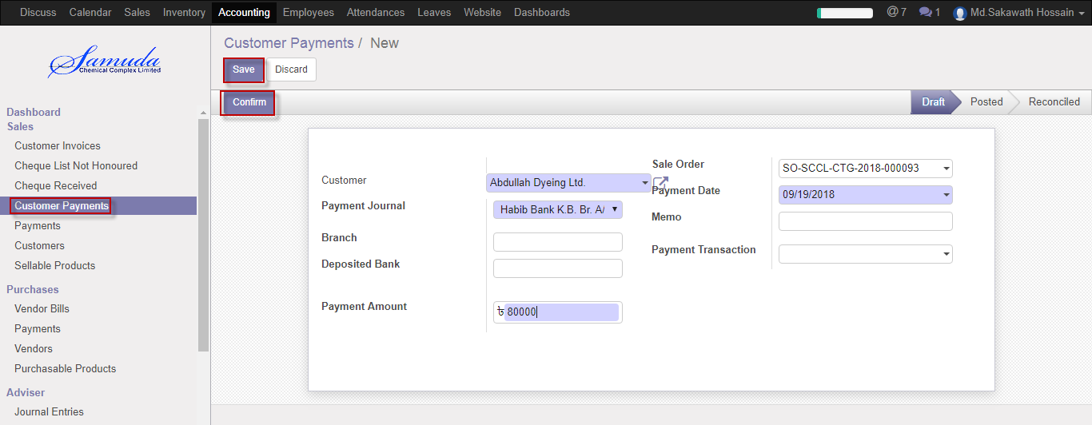

Figure: Create Customer payment

# 17. Cheque Received

Cheque received made by Accounts executive or Head of accounts. Those SO type is Cash then related DA against will make Cheque received.

## 17.1 Cheque Received by Accounts executive

Cheque received will be created/Edit by Accounts executive

We can create Cheque recived using the menu **Accounting>>sales>>Cheque Received ‣**and click **Create.**

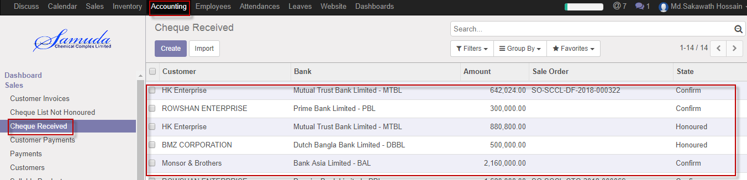Figure: Cheque received List view

We need to set the following:-

**Customer**: Select customer.

**Sale order:** Sale order will come auto after select customer or select manually.

**Payment journal:** Select payment journal.

**Date on Cheque:** Select date.

**Payment amount:** Enter payment amount.

**Bank:** Select Bank

**Branch Name:** Select branch name

**Cheque no:** Enter cheque no

**Currency:** Select currency.

After entering all information click **Save & Received**.

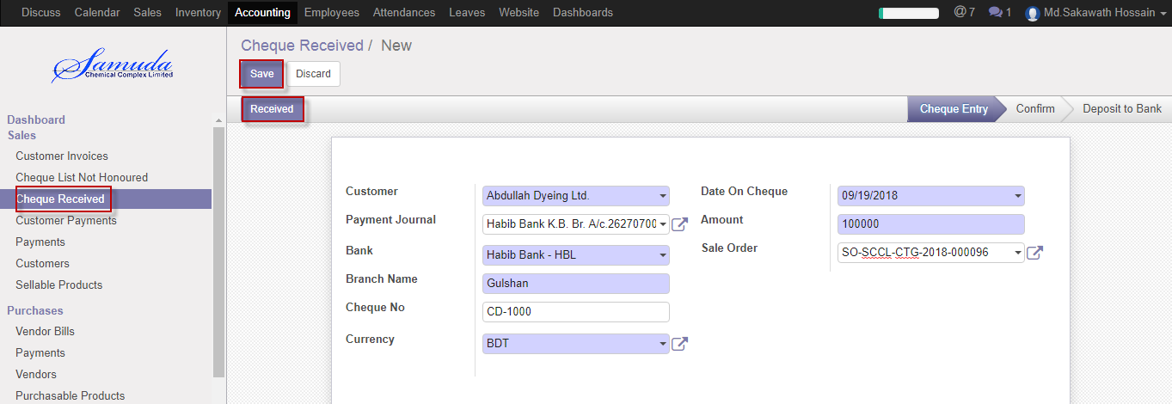

Figure: Create Cheque Received

# 18. Customer Invoice

Customer Invoice will ready and will come under customer invoice menu after confirm Delivery chalan.

Then Account executive will validate customer invoice.

## 18.1 Customer Invoice Validate by Accounts executive

To see the Customer Invoice request use the menu **accounting ‣ Customer Invoice**

Accounts Executive can Validate Customer Invoice. Accounts Executive Validate the request by click on **Validate** button

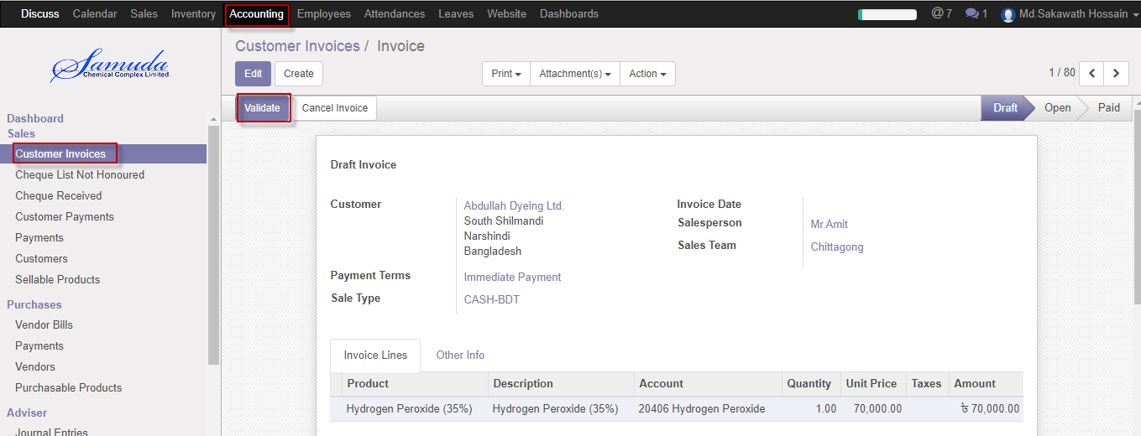

Figure: Customer Invoice list view for Validate

Accounts Executive is capable to cancel Customer Invoice by click **Cancel** Button.

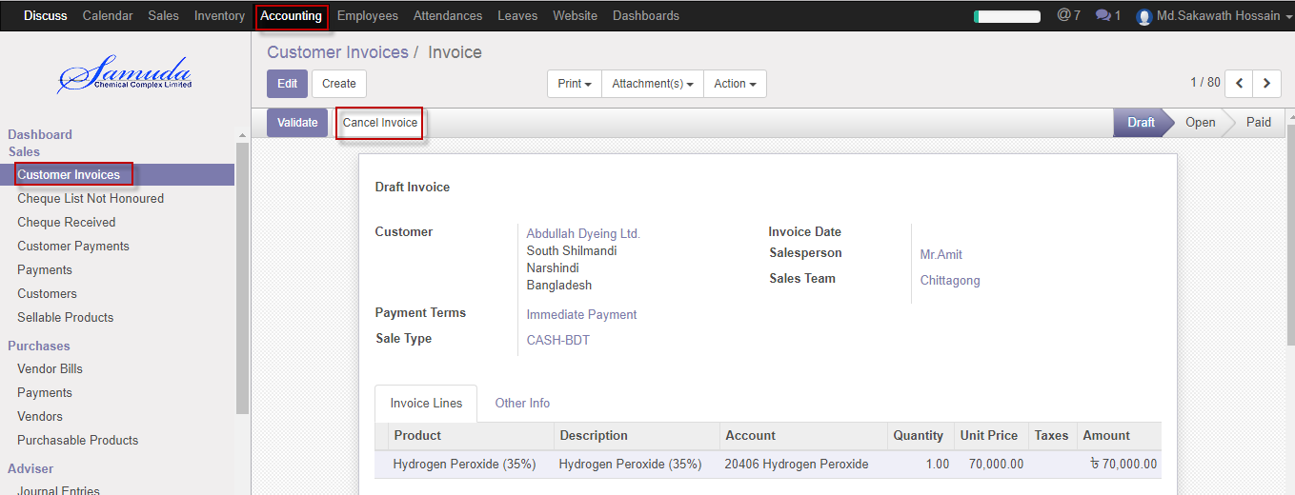

Figure: Customer Invoice cancel

# 19. Reports

In sales module reports contain all the sales related information. Reports document containing information graphic, or tabular form, prepared on ad hoc, periodic, recurring, regular, or as required basis.

## 19.1 Sales Order reports view by Sales executive

To see the sales order reports use the menu **Sales ‣Select sales order from list>** **Print>Quotation**

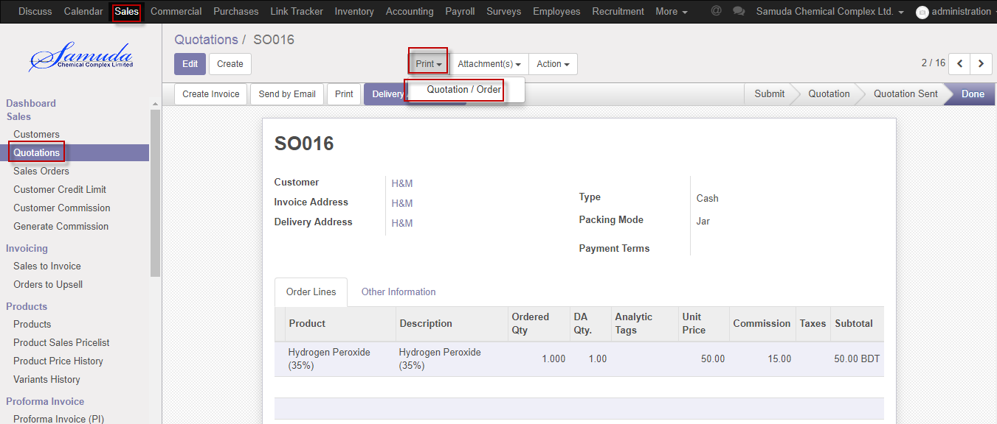

Figure: Sales order reports print view

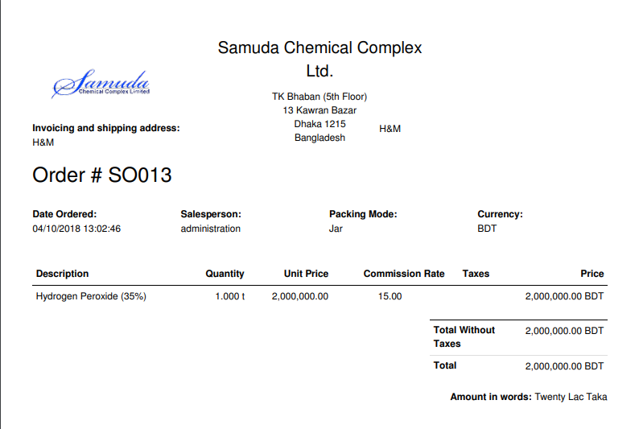

Figure: Sales order reports PDF format

## 19.2 Customer credit limit reports view by Admin

To see the customer credit limits reports use the menu **Sales ‣select customer credit limit from list>** **Print>Credit limit summary**

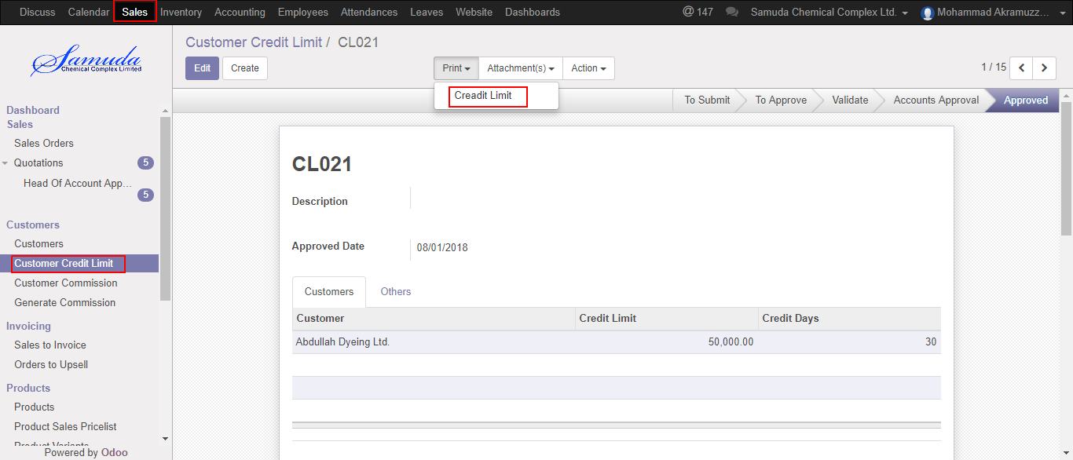

Figure: Customer credit limit reports print view

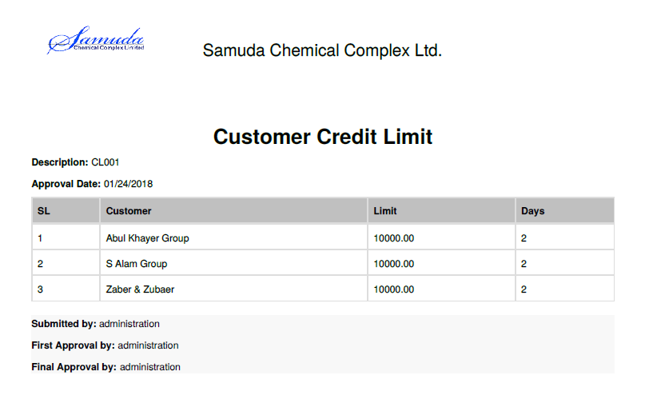Figure: Customer credit limit reports PDF format

## 19.3 Customer commission reports view by Admin

To see the customer commission reports use the menu **Sales ‣select customer commission from list>** **Print>Commission report**

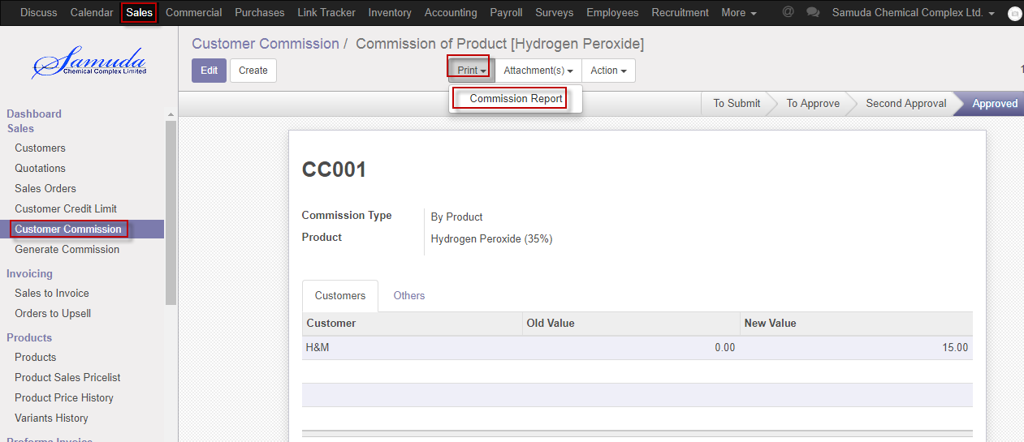

Figure: Customer commission reports print view

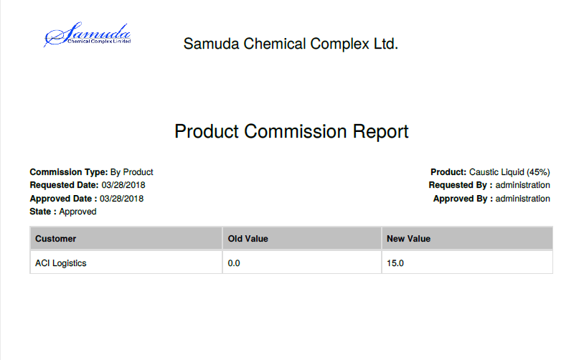

Figure: Customer commission reports PDF format

## 19.5 Product sales pricelist reports view by Sales executive

To see the product sales pricelist reports use the menu **Sales ‣select product sales pricelist from list>** **Print>Product pricelist**

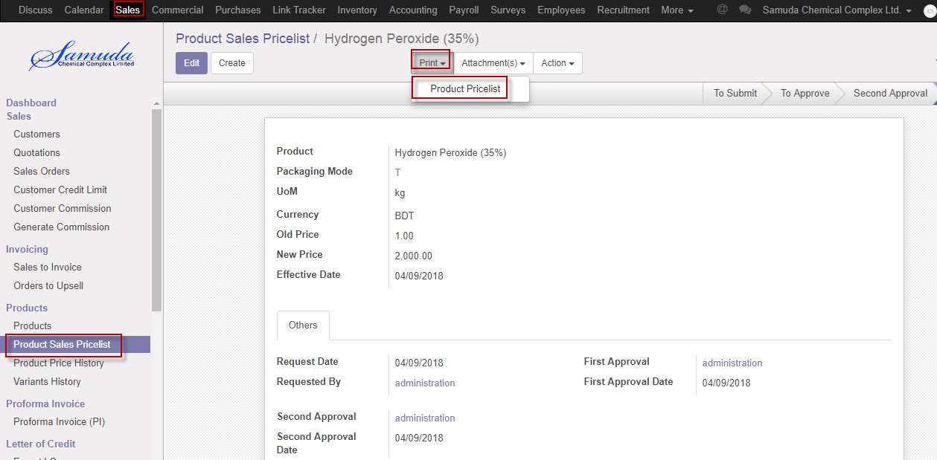

Figure: Product sales pricelist reports print view

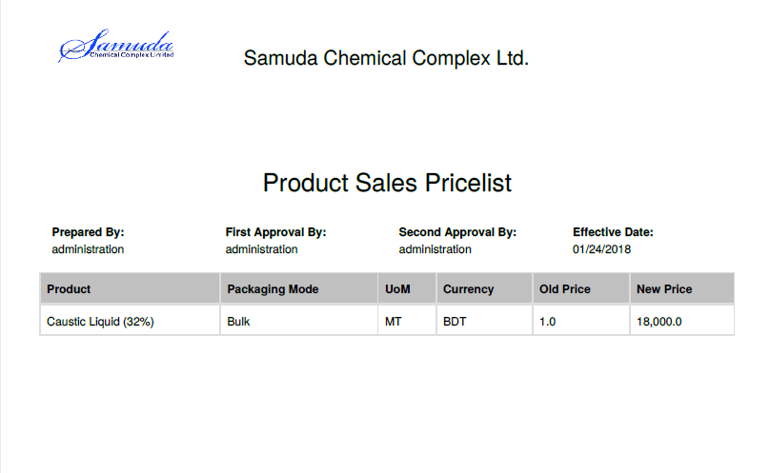

Figure: Product sales pricelist PDF format

## 19.6 Delivery authorization reports view by account head

To see the Delivery authorization reports use the menu **Sales ‣select Delivery authorization from list>** **Print>Delivery authorization**

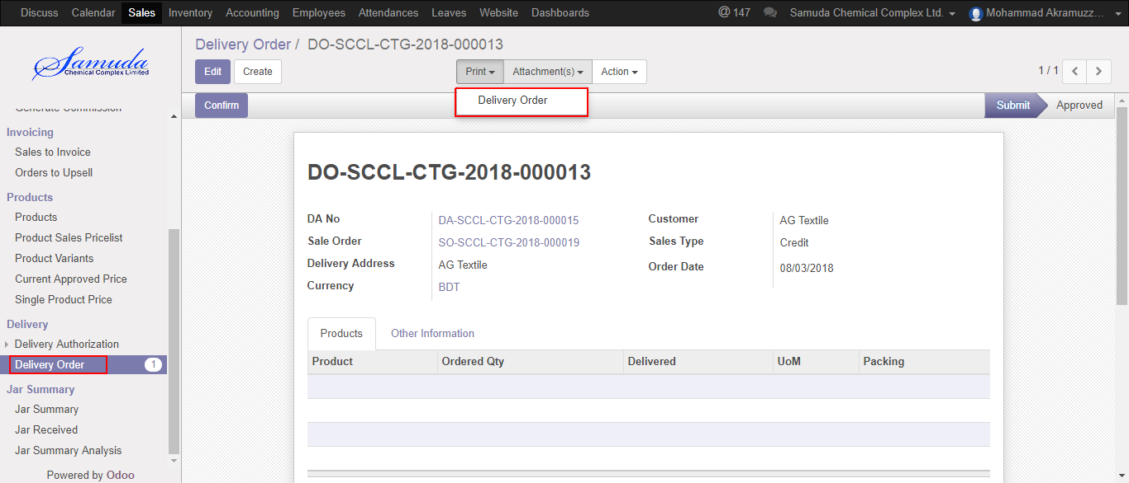

Figure: Delivery authorization reports print view

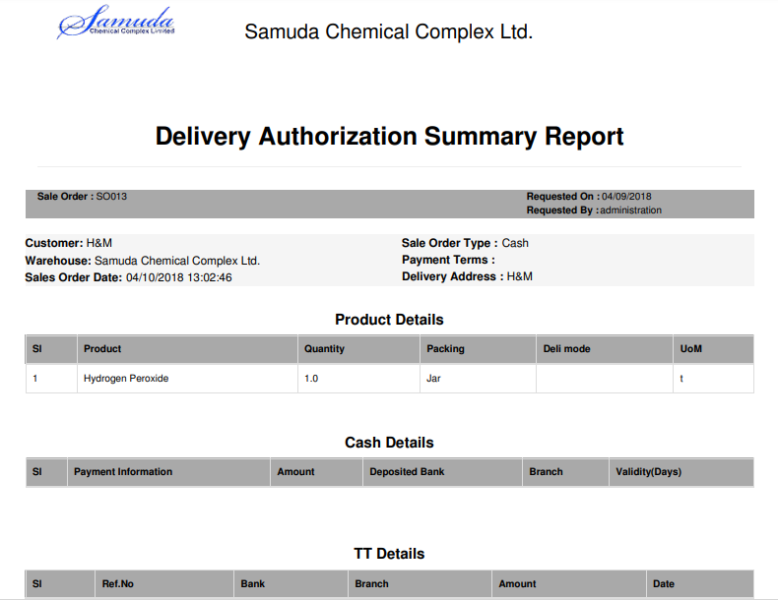

Figure: Delivery authorization reports PDF format

## 19.7 Sales reports view by sales executive

To see the Sales reports use the menu **Sales ‣Reports>Sales** >>Click to expand and Select an option to View reports

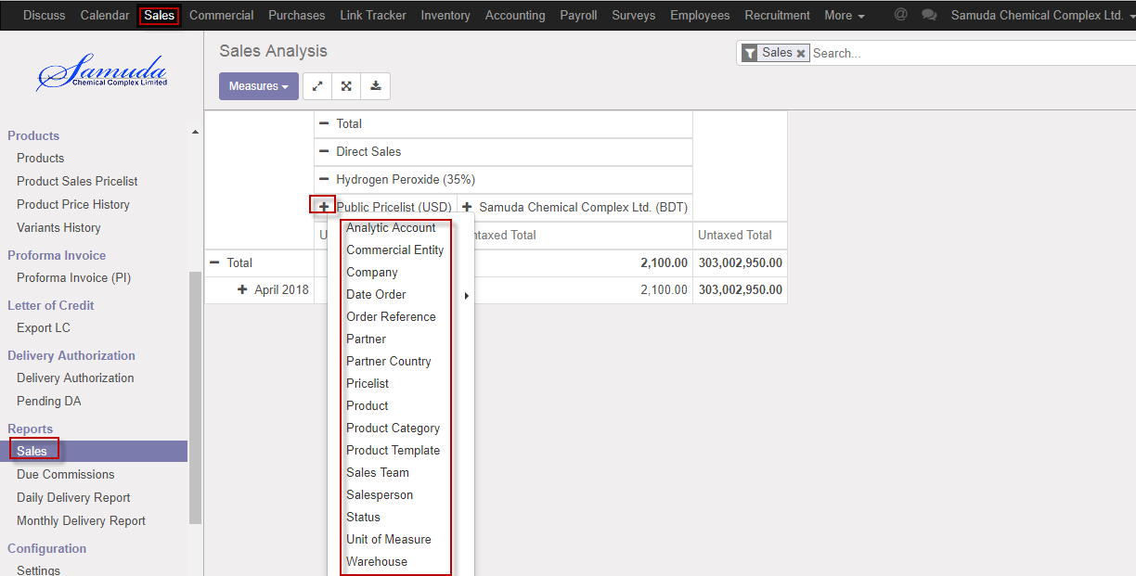

Figure: Sales print view

## 19.8 Daily reports view by Admin

To see the daily reports use the menu **Sales ‣Reports>** **Daily reports**

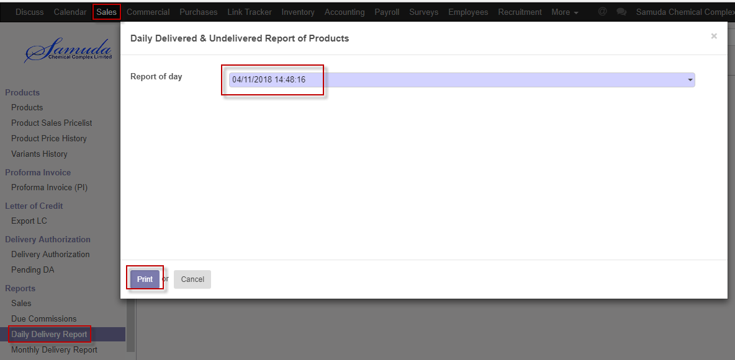

Figure: Daily reports print view

We need to set the following:-

**Report of day**: Select reports of day.

**A**fter entering all information click **Print**.

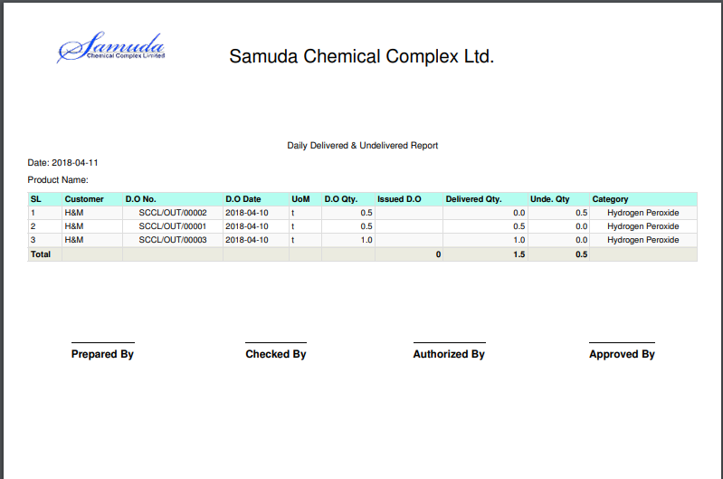

Figure: Daily reports PDF format

## 19.9 Monthly Daily reports view by Admin

To see the Monthly daily reports use the menu **Sales ‣Reports>Monthly Daily reports**

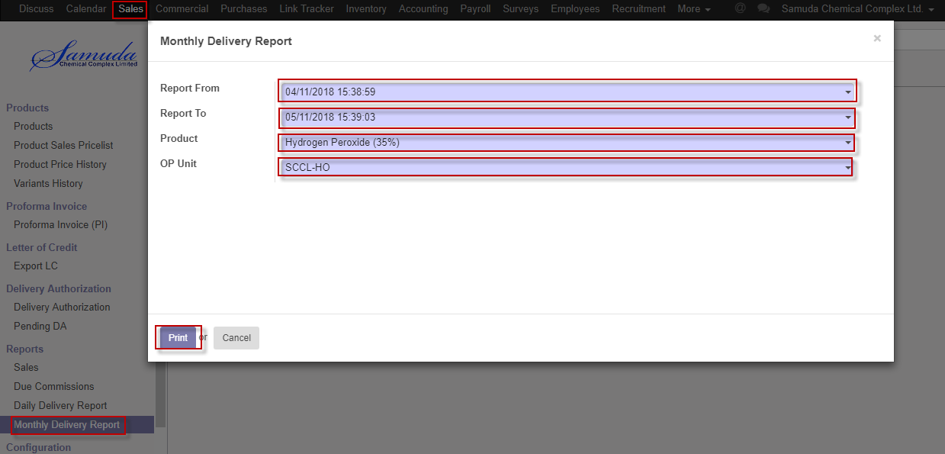

Figure: Monthly daily reports print view

We need to set the following:-

**Report from**: Select report from.

**Report To**: Select report to.

**Product**: Select product.

**OP unit**: Select OP unit.

After entering all information click **Print**.